# TITLE:

# Contributions of human activities to suspended sediment yield during storm events from a steep, small, tropical watershed

SSYEV, m3, km2, SSYUPPER, SSYLOWER, SSYTOTAL, SSYPRE, alpha, Beta, plus-minus, a, b

### Authors:

Messina, A.M.a*, Biggs, T.W.a

a San Diego State University, Department of Geography, San Diego, CA 92182, amessina@rohan.sdsu.edu, +1-619-594-5437, tbiggs@mail.sdsu.edu, +1-619-594-0902

## ABSTRACT

Shows that a small area disburbance (<1% of watershed area) can double sediment loads. Humans occupy only 5% of the watershed surface but increased SSY by ~4x

### Keywords:

Coral reefs, Drifters, Acoustic backscatter, Water circulation, Residence time

## Introduction

Human activities, including industry, agriculture, deforestation, roads, and urbanization alters the timing, composition, and amount of sediment loads to downstream ecosystems like coral reefs, causing enhanced sediment stress on corals near the outlets of impacted watersheds (Syvitski et al., 2005; West and van Woesik, 2001). Anthropogenic sediment disturbance may be particularly high in the humid tropics, which are characterized by high rainfall, extreme weather events, steep slopes, erodible soils, and naturally dense vegetation, where land clearing alters the fraction of exposed soil much more than in regions with sparse vegetation.

On Molokai, Stock et al. (2010) found that less than 5% of the land produces most of the sediment, and only 1% produces approx. 50% of the sediment (Risk, 2014), suggesting that management should focus on identifying, quantifying, and mediating erosion hotspots . Knowledge of fluvial suspended sediment yield (SSY) on most Pacific volcanic islands remains limited due to the challenges of in situ monitoring, and existing sediment yield models are not well-calibrated to the climatic, topographic, and geologic conditions found on steep, tropical islands (Calhoun and Fletcher, 1999). Developing models that predict SSY from small, mountainous catchments is a significant contribution for establishing baselines for change-detection, and can also further improve models applied at the regional scale (Duvert et al., 2012).

Traditional approaches to quantifying human impact on sediment yield, including comparison of total annual yields (Fahey et al., 2003) and sediment rating curves (Asselman, 2000; Walling, 1977), are complicated by interannual variability and hysteresis in the discharge-concentration relationship. As an alternative, other studies (Basher et al., 2011; Duvert et al., 2012) have compared total SSY generated by storm events of the same magnitude to detect human impacts and develop empirical models. SSY generated by individual storm events (SSYEV) may correlate with various precipitation and discharge variables ("storm metrics"), such as total precipitation, the Erosivity Index, total discharge, or maximum event discharge, but the best correlation has consistently been found with maximum event discharge. Several researchers have hypothesized that the maximum event discharge integrates the whole hydrological response of a watershed, making it a good predictor variable of SSYEV in diverse environments (Duvert et al., 2012; Rankl, 2004). High correlation between SSYEV and maximum event discharge has been found in semi-arid, temperate, and sub-humid watersheds in Wyoming (Rankl, 2004), Mexico, Italy, France (Duvert et al., 2012), and New Zealand (Basher et al., 2011; Hicks, 1990), but this approach has not been attempted for steep, tropical watersheds on volcanic islands.

The anthropogenic impact on SSY may vary by storm magnitude, as documented in Mediterranean climates (White and Greer, 2006) and in Pacific Northwest forests (Lewis et al., 2001). As storm magnitude increases, water yield and/or SSY from natural areas may increase relative to human-disturbed areas, diminishing anthropogenic impact relative to the natural baseline. While large storms account for most SSY in natural conditions, human-disturbed areas may show the most significant disturbance for smaller storms (Lewis et al., 2001). It is hypothesized that the disturbance ratio (DR) is highest for small storms, when background SSY from the undisturbed forest is low and erodible sediment from disturbed surfaces is the dominant source. For large storms, it is hypothesized mass movements and bank erosion contribute to naturally high SSY from the undisturbed watershed, reducing the DR for large events.

This study uses in situ measurements of precipitation, stream discharge, turbidity and suspended sediment concentration to quantify sediment yield from key areas of the watershed and to develop an empirical model of storm-generated sediment yield to a priority coral reef. Turbidity is used to model continuous suspended sediment concentration by developing a turbidity-suspended sediment concentration relationship (T-SSC). The T-SSC relationship is unique to each region, or even each stream, and can be influenced by water color, dissolved solids and organic matter, temperature, and the shape, size, and composition of sediment particles. However, T has proved to be a robust surrogate measure of SSC in streams (Gippel 1995) and is widely used for monitoring remote watersheds where sediment yield is dominated by flashy storm events, and monitoring resources are limited (Lewis 1996). The questions addressed include: How much has human disturbance increased sediment yield to the Faga'alu Bay? How do sediment contributions from human-disturbed areas and undisturbed areas vary with storm size? And Which is the best predictor of storm event suspended sediment yield (SSYEV): total precipitation, Erosivity Index, total discharge, or maximum event discharge?

## Study Area

The study watershed, Faga'alu, drains an area of 1.86km2 on Tutuila (14S, 170W), the largest island in the Territory of American Samoa (140 km2). Most of Tutuila is composed of steep, heavily forested mountains, and as a result the mean slope of Faga'alu watershed is XX m/m and total relief is 653m. Monitoring efforts focused on Faga'alu Stream, which discharges to an adjacent reef that Aeby et al. (2006) identified as being highly degraded by sediment. Faga'alu watershed was identified by local environmental management agencies in the Land-Based Sources of Pollution working group of the American Samoa Coral Reef Advisory Group (CRAG) as a heavily impacted watershed, and was selected by the US Coral Reef Task Force (USCRTF) as a Priority Watershed for conservation and remediation efforts.



Figure 1. Faga'alu watershed showing the Uupper (undisturbed) and Lower (human-disturbed) subwatersheds.

### Climate

Precipitation is caused by major storms including cyclones and tropical depressions, isolated thunderstorms, and orographic uplifting of trade-wind squalls over the high (300-600m), mountainous ridge that runs the length of the island. Unlike many other Pacific Islands, the mountainous ridge runs parallel to the predominant wind direction, and does not cause a significant windward/leeward rainfall gradient. When controlling for drainage area, average annual specific discharge (m3/yr/km2) shows little spatial variation across the island, irrespective of location or orientation (Dames & Moore, 1981). Precipitation varies orographically from an average 6,350mm/yr at high elevation to 2,380mm/yr at the shoreline, averaging 3,800mm/yr over the island from 1903 to 1973 (Eyre, 1994; Izuka, 2005). In Faga'alu watershed, rainfall records show average annual precipitation is 6,350 mm at Matafao Mtn. (653m m.a.s.l), 5,280mm at Matafao Reservoir (249m m.a.s.l.) and about 3,800mm on the coastal plain (Craig, 2009; Dames & Moore, 1981; Tonkin & Taylor International Ltd., 1989; Wong, 1996, Perrault, 2010). Potential evapotranspiration follows the opposite trend, with annual mean PET varying from 890mm at high elevation to 1,150mm at sea level (Izuka, 2005). Tropical cyclones are erratic but occurred on average every 1-13 years from 1981-2014 (Craig, 2009) and bring intense rainfall, flooding, landslides, and high sediment yield events (Buchanan-Banks, 1979).

There are two subtle rainfall seasons: a drier winter season, from June through September and a wetter summer season, from October through May (Izuka, 2005). During the drier winter season, the island is influenced by the southeast Trades and relatively stronger, predominantly East to Southeast winds, lower temperatures, lower humidity and lower total rainfall. During the wetter summer season the Inter-Tropical Convergence Zone (ITCZ) moves over the island, causing light to moderate Northerly winds, higher temperatures, higher humidity, and higher total rainfall. While total rainfall is lower in the drier Tradewind season, large rainfall events are still observed. Analysis of mean monthly rainfall data from USGS rain gauges and Parameter-elevation Relationships on Independent Slopes Model (PRISM) Climate Group (Daly et al., 2006) for the period 1971-2000 showed 75% of precipitation occurred in the wet seaons, October-May, and 25% occurred in the dry season, June-September (Perrault, 2010). Analysis of 212 peak discharges at 11 continuous-record gaging sites up to 1990 showed 65% of annual peak flows occurred during the summer wet season and 35% of peak flows occurred during the drier Tradewind season (Wong, 1996).

### Land Use

Faga'alu watershed can be divided into two subwatersheds: 1) an upper subwatershed characterized by large areas of undisturbed, steeply-sloping, heavily forested hillsides (UPPER), and 2) a lower subwatershed wtih similarly steep forested topography and relatively small flat areas that are urbanized or densely settled (LOWER) (Figure 1). This settlement pattern is typical for volcanic islands with steep topography in the south Pacific. Land use in Faga'alu watershed includes agriculture, roads, and urbanization (Table 1), but the predominant land cover is undisturbed forest on the steep hillsides (84.5%).

The Faga'alu watershed includes two unique features not found in "typical" watersheds in American Samoa: 1) an open aggregate quarry (upstream of FG2 in Figure 1), and 2) a large impervious area associated with a hospital (adjacent FG3 in Figure 1). Three water impoundment structures were built in the UPPER subwatershed for drinking water supply and hydropower but only the highest, Matafao Reservoir, was ever connected to the municipal water system and has since fallen out of use (Tonkin & Taylor International Ltd., 1989)(Figure 1). A full description of stream impoundments is in the Appendix.

Natural landsliding in undisturbed forest can contribute large amounts of sediment during storm events (Buchanan-Banks, 1979; Calhoun and Fletcher, 1999). Compared to other watersheds on Tutuila, a relatively large portion of Faga'alu watershed is urbanized (=4.6% "High Intensity Developed" in Table 1), due to large areas of impervious surface associated with the hospital and the numerous residences and businesses. A small portion of the watershed (1.1%) is developed open space, which includes landscaped lawns and parks. In addition to some small, household gardens there are several small agricultural areas growing banana and taro on the steep hillsides. A land cover map (2.5m res.) classified the agricultural plots as "Grassland" due to the high fractional grass cover in the plots (Table 1) (NOAA Ocean Service and Coastal Services Center, 2010). These plots are currently receiving technical assistance from the Natural Resource Conservation Service (NRCS) to mitigate erosion problems.

|  |  |  |  |  |  |  |  |  |  |  |  |  |
| --- | --- | --- | --- | --- | --- | --- | --- | --- | --- | --- | --- | --- |
| Table 1. Land use categories in Faga'alu subwatersheds (NOAA Ocean Service and Coastal Services Center, 2010) | | | | | | | | | | | | |
| Subwatershed | Cumulative Area km2 | Cumulative % | Area km2 | % of area | % Bare Land | % High Intensity Developed | % Developed Open Space | % Grassland (agriculture) | % Forest | % Scrub/ Shrub | % Disturbed | % Undisturbed |
| FOREST(UPPER) | 0.9 | 0.48 | 0.9 | 48.0 | 0.4 | 0.0 | 0.0 | 0.1 | 82.4 | 17.1 | 0.4 | 99.6 |
| QUARRY(LOWER) | 1.17 | 0.63 | 0.27 | 14.5 | 5.7 | 0.7 | 0.1 | 0.5 | 92.1 | 0.9 | 6.5 | 93.5 |
| VILLAGE(LOWER) | 1.78 | 0.95 | 0.6 | 32.5 | 0.2 | 3.6 | 1.1 | 0.1 | 84.5 | 10.5 | 4.9 | 95.1 |
| Fagaalu Stream | 1.86 | 1.0 | 0.08 | 4.5 | 1.0 | 4.6 | 1.1 | 0.2 | 84.5 | 8.6 | 6.8 | 93.2 |

An open-pit aggregate quarry, covering 1.6ha (5.7% of Quarry subwatershed) accounts for the majority of the 1.0% of Faga'alu watershed classified as Bare Land (Table 1). The quarry has been in continuous operation since the 1960's by advancing into the steep hillside to quarry the underlying basalt formation (Latinis 1996). In 2011 the quarry operators installed some sediment runoff management practices such as silt fences and settling ponds (Horsley-Witten, 2011) but they were unmaintained and inadequate to control the large amount of sediment mobilized by the intense tropical rains (Horsley-Witten, 2012a). Longitudinal sampling of Faga'alu stream in 2011 showed significantly increased turbidity downstream of the quarry (FG2) and of a new bridge construction site on the village road approximately 200m downstream of FG2 (Curtis et al., 2011). Construction of the bridge was completed March 2012 and no longer increases turbidity. There are several small footpaths and unpaved driveways, but most unpaved roads are stabilized with compacted gravel and do not appear to be a major contributor of sediment (Horsley-Witten, 2012b).



Figure 2. Photos of the open aggregate quarry in Faga'alu in 2012 (Top) and 2014 (Bottom). Photo: Messina

## Methods

A nested-watershed approach was used to quantify the contribution of SSY from undisturbed and human-disturbed areas to total SSY to Faga'alu Bay during baseflow, and during storm events of varying magnitude (SSYEV). While steep, mountainous streams can discharge large amounts of bedload (Milliman and Syvitski, 1992), this research is focused on sediment size fractions that can be transported in suspension in the marine environment to settle on corals, and this is generally restricted to silt and clay fractions (<16um) (Asselman, 2000).

SSY generated by individual storm events (SSYEV) can be used to assess the contribution of individual subwatersheds to total SSY (Zimmermann et al., 2012), compare the responses of different watersheds to "storm metrics" (Basher et al., 2011; Duvert et al., 2012; Fahey et al., 2003; Hicks, 1990), and determine changes in SSY from the same watershed over time (Bonta, 2000). SSYEV is calculated by integrating continuous estimates of suspended sediment yield, calculated from measured or modeled water discharge (Q) and measured or modeled suspended sediment concentration (SSC) (Duvert et al., 2012):

|  |  |  |
| --- | --- | --- |
|  |  | Equation 1 |
| where SSYEV is suspended sediment yield (tons) from t=0=storm start to T=storm end, SSC is suspended sediment concentration (mg/L), and Q is water discharge (L/sec). | | |

### Quantifying SSY from disturbed and undisturbed subwatersheds

To assess the contribution of the UPPER and LOWER subwatersheds to total SSY from Faga'alu watershed, the percent contributions were calculated from the UPPER, undisturbed subwatershed (SSYUPPER=SSYFG3), and the LOWER, human-disturbed subwatershed (SSYLOWER) for storm events with available data at both gaging locations (FG1 and FG3-Figure 1). SSYLOWER, which includes the quarry and village areas, was calculated by subtracting SSY measured at FG1 from SSY measured at FG3 (SSYLOWER = SSYFG3 - SSYFG1). Where SSYEV data at FG2 were also available, the contribution from the quarry subwatershed (SSYQUARRY=SSYFG1 - SSYFG2) could be compared to the contribution from village and forest areas in the LOWER watershed, where SSYLOWER=SSYFG3-SSYFG2).

The disturbance ratio (DR) is the ratio of SSYEV from the total human-disturbed watershed under current conditions, SSYTOTAL (measured at the watershed outlet FG3), to SSY under pre-disturbance conditions (SSYPRE):

|  |  |  |
| --- | --- | --- |
|  |  | Equation 2 |

SSYPRE is calculated assuming that the specific SSY (Mg/km2) from forested parts of the LOWER watershed is similar to the specific SSY from the UPPER watershed:

|  |  |  |
| --- | --- | --- |
|  |  | Equation 3 |

The percent contribution and DR were calculated for each storm event and averaged to determine the relative contributions from the UPPER and LOWER subwatersheds to total SSY.

### Predicting event suspended sediment yield (SSYEV)

SSYEV may be correlated with precipitation or discharge variables, so four "storm metrics" were tested: total event precipitation (Psum), event rainfall erosivity (EI30) (Hicks, 1990), total event water discharge (Qsum), and peak event water discharge (Qmax) (Duvert et al., 2012; Rodrigues et al., 2013). SSYEV and the discharge metrics (Qsum and Qmax) were normalized by watershed area.

The relationship between SSYEV and storm metrics may be a linear function, but is often best fit by a watershed-specific power law function of the form:

|  |  |  |
| --- | --- | --- |
|  |  | Equation 4 |
| where X is a storm metric, and the regression coefficients α and β are obtained by ordinary least squares regression on the logarithms of SSYEV and X (Basher et al., 2011; Duvert et al., 2012; Hicks, 1990). | | |

Storm metrics may be linearly or nonlinearly correlated with SSYEV, so both Pearson's and Spearman's correlation coefficients were calculated to select the best predictor of SSYEV from the total watershed, and from each subwatershed. Model fits for each storm metric were compared using coefficients of determination (r2) and Root Mean Square Error (RMSE).

### Data Collection

Data on precipitation, water discharge, suspended sediment concentration and turbidity were collected during three field campaigns: January-March, 2012, February-July 2013, and January-March 2014.

#### Precipitation

Precipitation (P) was measured at three locations in Faga'alu watershed using two Rainwise RAINEW tipping-bucket rain gages recording at 1 min intervals (RG1 and RG2), or at the Vantage Pro Weather Station (Wx) at 15 min intervals (Figure 1). Data at RG2 was only recorded January-March, 2012, to determine a relationship between elevation and precipitation. Precipitation at 15 min intervals from Wx was used to fill any data gaps in the precipitation recorded at RG1.The total event precipitation (Psum) and event rainfall erosivity (EI30) were calculated using data from RG1, with data gaps filled by data from Wx.

#### Water Discharge

Water discharge (Q) in Faga'alu Stream was derived from 15 min interval stream stage measurements, using a stage-discharge rating curve calibrated to manual Q measurements made under baseflow and stormflow conditions. Stream stage was measured with non-vented pressure transducers (PT) (Solinst Levelogger or Onset HOBO Water Level Logger) installed in stilling wells at two locations in Faga'alu: FG1 and FG3. Stream gaging sites were chosen to take advantage of an existing control structure (FG1) and a stabilized stream cross section (FG3). Barometric pressure data to calculate stage from the PT's was collected at Wx. Data gaps in barometric pressure were filled by data from stations at Pago Pago Harbor (NSTP6) and NOAA Climate Observatory at Tula (TULA). Priority was given to the station closest to the watershed with valid barometric pressure data. Barometric data were highly correlated and the source data made little (<1cm) difference in the resulting water level.

Discharge (Q) was measured in the field by the area-velocity method (AV) using a Marsh-McBirney flowmeter to measure flow velocity, and simultaneous channel surveys to measure cross-section geometry (Harrelson et al., 1994; Turnipseed and Sauer, 2010). AV measurements were made at FG1 and FG3 in Faga'alu, and linear, log-linear, and nonlinear rating curves were tested for best fit. AV measurements could not be made at high stages at FG1 and FG3 for safety reasons, and peak stages were far higher the highest manual stage-Q measurements. The stream cross-section at FG3 is a channelized rectangular channel with stabilized rip-rap banks and bed (Appendix Figure 1), so the stage-discharge rating at FG3 was extrapolated using Manning's equation by calibrating Manning's n to the manual AV measurements. The flow control structure at FG1 is a masonry ogee spillway crest of a defunct stream capture. The structure is a rectangular channel 43 cm, then transitions abruptly to gently sloping banks, causing an abrupt change in the stage-Q relationship (Appendix Figure 2). The flow control structure at FG1 did not meet the assumptions for modeling Q with Manning's equation so the rating was modeled with HEC-RAS (Brunner, 2010) and calibrated to the manual AV measurements (CITATION?). Water discharge at FG2 was calculated from the Q data at FG1. The specific water discharge from FG1 (Qm3/0.9km2) was multiplied by the watershed area draining to FG2 (1.17km2).

#### Storm Events

Storm events can be defined by precipitation (Hicks, 1990) or discharge parameters (Duvert et al., 2012), and the method used to separate storm events on the hydrograph can significantly influence the analysis of SSYEV (Gellis, 2013). Complex graphical or rule-based techniques for hydrograph separation may be implemented (Dunne and Leopold, 1978; Perrault, 2010), but for this research the simple stage height threshold rule was used due to the flashy hydrologic response, low baseflow discharge, and short duration of recession curves between events (Fahey et al., 2003; Lewis et al., 2001). A storm event is defined as the period of time where stream stage height exceeds a chosen threshold. Complex storm events are defined when subsequent rainfall events occur before the stream stage falls below the storm threshold. These events can be separated manually into individual storms for analysis, but requires the discretion of the analyst (Duvert, 2012).

#### Suspended Sediment Concentration and Turbidity

Stream water samples for SSC were collected by grab or "dip" sampling with 500mL HDPE bottles at FG1, FG2, and FG3. At FG2, water samples were also collected at 30 min intervals by an ISCO 3700 Autosampler triggered by a stage height sensor. Samples were analyzed on-island using gravimetric methods (Gray et al., 2000). Water samples were vacuum filtered on 47mm diameter, 0.7um Millipore AP40 glass fiber filters, oven dried at 100C for one hour, cooled and weighed to determine SSC (mg/L).

Suspended sediment concentration (SSC) at 15 min intervals was derived from 1) 15 min interval turbidity (T) data, using a T-SSC relationship calibrated to stream water samples collected over a range of Q and SSC, and 2) interpolating SSC from grab and autosamples. Interpolated SSC for storm events could only be calculated if more than three samples were collected during the storm event, and if they adequately captured the SSC dynamics of the storm event. SSC was assumed to be zero at the beginning and end of each storm if no grab sample data was available (Lewis 2001). The T-SSC relationship is unique to each region, or even each stream, and can be influenced by water color, dissolved solids and organic matter, temperature, and the shape, size, and composition of sediment particles. However, T has proved to be a robust surrogate measure of SSC in streams (Gippel 1995) and is most accurate when a unique T-SSC relationship is developed for each instrument separately using in situ grab samples under storm conditions (Lewis 1996).

Turbidity (T) was measured at FG1 and FG3 using three types of turbidimeters: 1) a Greenspan TS3000 (TS), 2) a YSI 600OMS with 6136 turbidity probe (YSI), and 3) a CampbellSci OBS500 (OBS). All turbidimeters were permanently installed in protective PVC housings near the streambed where the turbidity probe would be submerged at all flow conditions, and oriented downstream. Despite regular maintenance, debris fouling during storm and baseflows was common and caused data loss during several storm events. Storm events with incomplete or invalid T data were not used in the analysis. A three-point calibration was performed on the YSI turbidimeter with YSI NTU standards (0, 126, and 1000) at the beginning of each successive field season, approximately every 3-6 months during data collection. Turbidity measured with 100 and 1000 NTU standards differed by less than 10% (4-8%) during each recalibration. The TS turbidimeter was vandalized and removed from service before recalibration. All turbidimeters were regularly cleaned following storms to ensure proper operation.

At FG3, a YSI recorded T (NTU) at 5 min intervals from January 30, 2012, to February 20, 2012, and at 15 min intervals from February 27, 2012 to May 23, 2012, when it was damaged during a large storm. The YSI turbidimeter was replaced with an OBS which recorded Backscatter (BS) and Sidescatter (SS, comparable to NTU) at 5 min intervals from March 7, 2013, to July 15, 2014. Both BS and SS were analyzed to determine which showed the best relationship with SSC. No data was recorded from August 2013-January 2014 due to instrument malfunction (wiper clogged with sediment). A new OBS was installed at FG3 from January, 2014, to August, 2014. To correct for some periods of high scatter observed in the BS and SS data recorded by the OBS in 2013, the new OBS was programmed to make 100 BS and SS measurements every 15Min, and record Median, Mean, STD, Min, and Max BS and SS. All BS and SS parameters were analyzed to determine which showed the best relationship with SSC.

At FG1, a TS recorded T (NTU) at 5 min intervals from January 2012-July 2012, when it was vandalized and destroyed. The YSI turbidimeter previously deployed at FG3 in 2012 was repaired and redeployed at FG1 and recorded T (NTU) at 5 min intervals from June 2013 to October 2013, and January 2014 to August 2014. Turbidity data was resampled to 15 min intervals to compare with SSC samples for the T-SSC relationship, and corresponding to Q for calculating suspended sediment yield (SSY) (Equation 1).

It is assumed that contributing sediment sources change during storm periods, and spatially in the watershed, so a unique T-SSC relationship was developed for each turbidimeter at each location using 15 min interval T data and SSC samples from storm periods only. A "synthetic" T-SSC relationship (SRC) was also developed by placing the turbidimeter in a black tub, and sampling T and SSC as sediment was added. An SRC was developed for the YSI turbidimeter at FG3 and the OBS at FG1, in 2014, using sediment collected from the streambed near the turbidimeter. An SRC was not developed for the TS turbidimeter at FG1, or the YSI turbidimeter when it was installed at FG3 in 2012. The results from the SRC's were not comparable to T-SSC relationships developed under actual storm conditions and were not used in further analyses.

### Measurement Uncertainty

Uncertainty in SSYEV estimates arises from both measurement and model errors, including models of stage-discharge (stage-Q) and turbidity-suspended sediment concentration (T-SSC) (Harmel et al., 2006). The Root Mean Square Error (RMSE) method estimates the "most probable value" of the cumulative or combined error by propagating the error from each measurement and modeling procedure to the final SSYEV estimate (Topping, 1972). The resulting cumulative probable error (PE) is the square root of the sum of the squares of the maximum values of the separate errors:

|  |  |  |
| --- | --- | --- |
|  |  | Equation 5 |
| where PE is the cumulative probable error for individual measured values (±%), EQmeas = uncertainty in Q measurements (±%), ESSCmeas = uncertainty in SSC measurements (± %), EQmod = uncertainty in Q modeled by the Stage-Q relationship (RMSE, as ±% of the mean observed Q), ESSCmod = uncertainty in SSC modeled by the T-SSC relationship (RMSE, as ± % of the mean observed SSC)(Harmel et al., 2009). | | |

Error from manual water discharge measurements using the Area-Velocity method, from continuous discharge measurment in a natural channel, from grab sampling and autosampling SSC during stormflows , and from lab procedures are considered "measurement errors" and were estimated using lookup tables from the DUET-H/WQ software tool (Harmel et al., 2006). These measurement errors (RMSE) were combined with the modeling errors (RMSE) from the stage-Q and T-SSC relationships to calculate PE for each storm event, to add a statistical measure of uncertainty to SSYEV (plus-minus tons). The effect of uncertain SSYEV estimates may complicate conclusions about contributions from subwatersheds, anthropogenic impacts, and SSYEV-Storm Metric relationships. This is common in sediment yield studies where successful models estimate SSY with plus-minus 50-100% accuracy (Duvert et al., 2012). Preliminary data and field observations suggested the difference in SSYEV from the upper and lower subwatersheds is significantly larger than the ranges of uncertainty in the SSY estimates.

## Results and Discussion

### Field Data Collection

#### Precipitation

Annual precipitation measured at RG1 (gaps filled with data from Wx) was 3349mm, 3443mm, and 3765 in 2012, 2013, and 2014 respectively. These annual rainfall amounts are approximately 75% of long-term rainfall data (=4500-4800mm) from the PRISM Climate Group (Craig, 2009). Comparison of rain gauge data showed no orographic relationship between RG1 and Wx, or RG1 and RG2, so precipitation was assumed to be homogenous over the watershed for all analyses. Rain gauges could only be placed as high as ~300m (RG2), though the highest point in the watershed is ~600m. Long-term rain gage records show a strong precipitation gradient with increasing elevation, with average precipitation of 3,000-4,000mm on the lowlands, increasing to more than 6,350mm at the high elevations (>400 m.a.s.l.) around the harbor (Craig, 2009; Dames & Moore, 1981; Wong, 1996). Rainfall data measured at higher elevations would be useful to determine a more robust orographic rainfall relationship. For this analysis, however, precipitation is only used as a predictive storm metric, and the absolute values of total rainfall in each subwatershed are not as important.

#### Water Discharge

At FG1, recorded stage varied from 1 to 120cm. Manual discharge measurements (n= 22) were made from 22 to 262 L/sec, covering a range of stages from 6 to 17cm. Since the highest recorded stage (120cm) was much higher than the highest stage with measured Q (17cm), and there was a distinct change in channel geometry above 43 cm (Appendix Figure 2) the rating could not be extrapolated by mathematical methods like a power law (CITATION??). The flow structure did not meet the assumptions for using Manning's equation to predict flow so the HEC-RAS model was used. The surveyed geometry of the upstream channel and flow structure at FG1 was input to HEC-RAS, and the HEC-RAS model was calibrated to the manual Q measurements (Figure 3). While a power function fit measured Q better than HEC-RAS for low flow, HEC-RAS fit better at high Q, above the storm threshold (Figure 3).The RMSE for the HEC-RAS model and Q measurements was 22 %, which was used to calculate the total Probable Error.

At FG1, recorded stage varied from 1 to 147cm. Manual discharge measurements (n= 14) were made from 30 to 1558 L/sec, covering a range of stages from 6 to 39cm. The highest recorded stage was much higher than the highest stage with measured Q so the rating could not be extrapolated by mathematical methods. The rating at FG1 was extrapolated using Manning's equation and surveyed stream geometry. Manning's n parameter was calibrated using the manual Q measurements (Figure 4). The RMSE for Mannings modeled Q and Q measurements was 32 (L/sec), which is used to calculate the total Probable Error. The RMSE for the AV measurements (FG1 and FG3) from the DUET/WQ look-up table (Harmel et al., 2006) was 8.5 %.

Discharge at both FG1 and FG3 was characterized by periods of low but perennial baseflow (FG1: 4-165 L/sec; FG3: 21-364 L/sec), punctuated by short, flashy hydrograph peaks (FG1: max 8356 L/sec, FG3: max 13071 L/sec).



Figure 3. Stage-Discharge relationships for stream gaging site at FG1 for (a) the full range of observed stage and (b) the range of stages with AV measurements of Q. "Channel Top" refers to the point where the rectangular channel transitions to a sloped bank and cross-sectional area increases much more rapidly with stage. A power-law relationship is also displayed to illustrate the potential error that could result if inappropriate methods are used.



Figure 4. Stage-Discharge relationships for stream gaging site at FG3 for (a) the full range of observed stage and (b) the range of stages with AV measurements of Q.

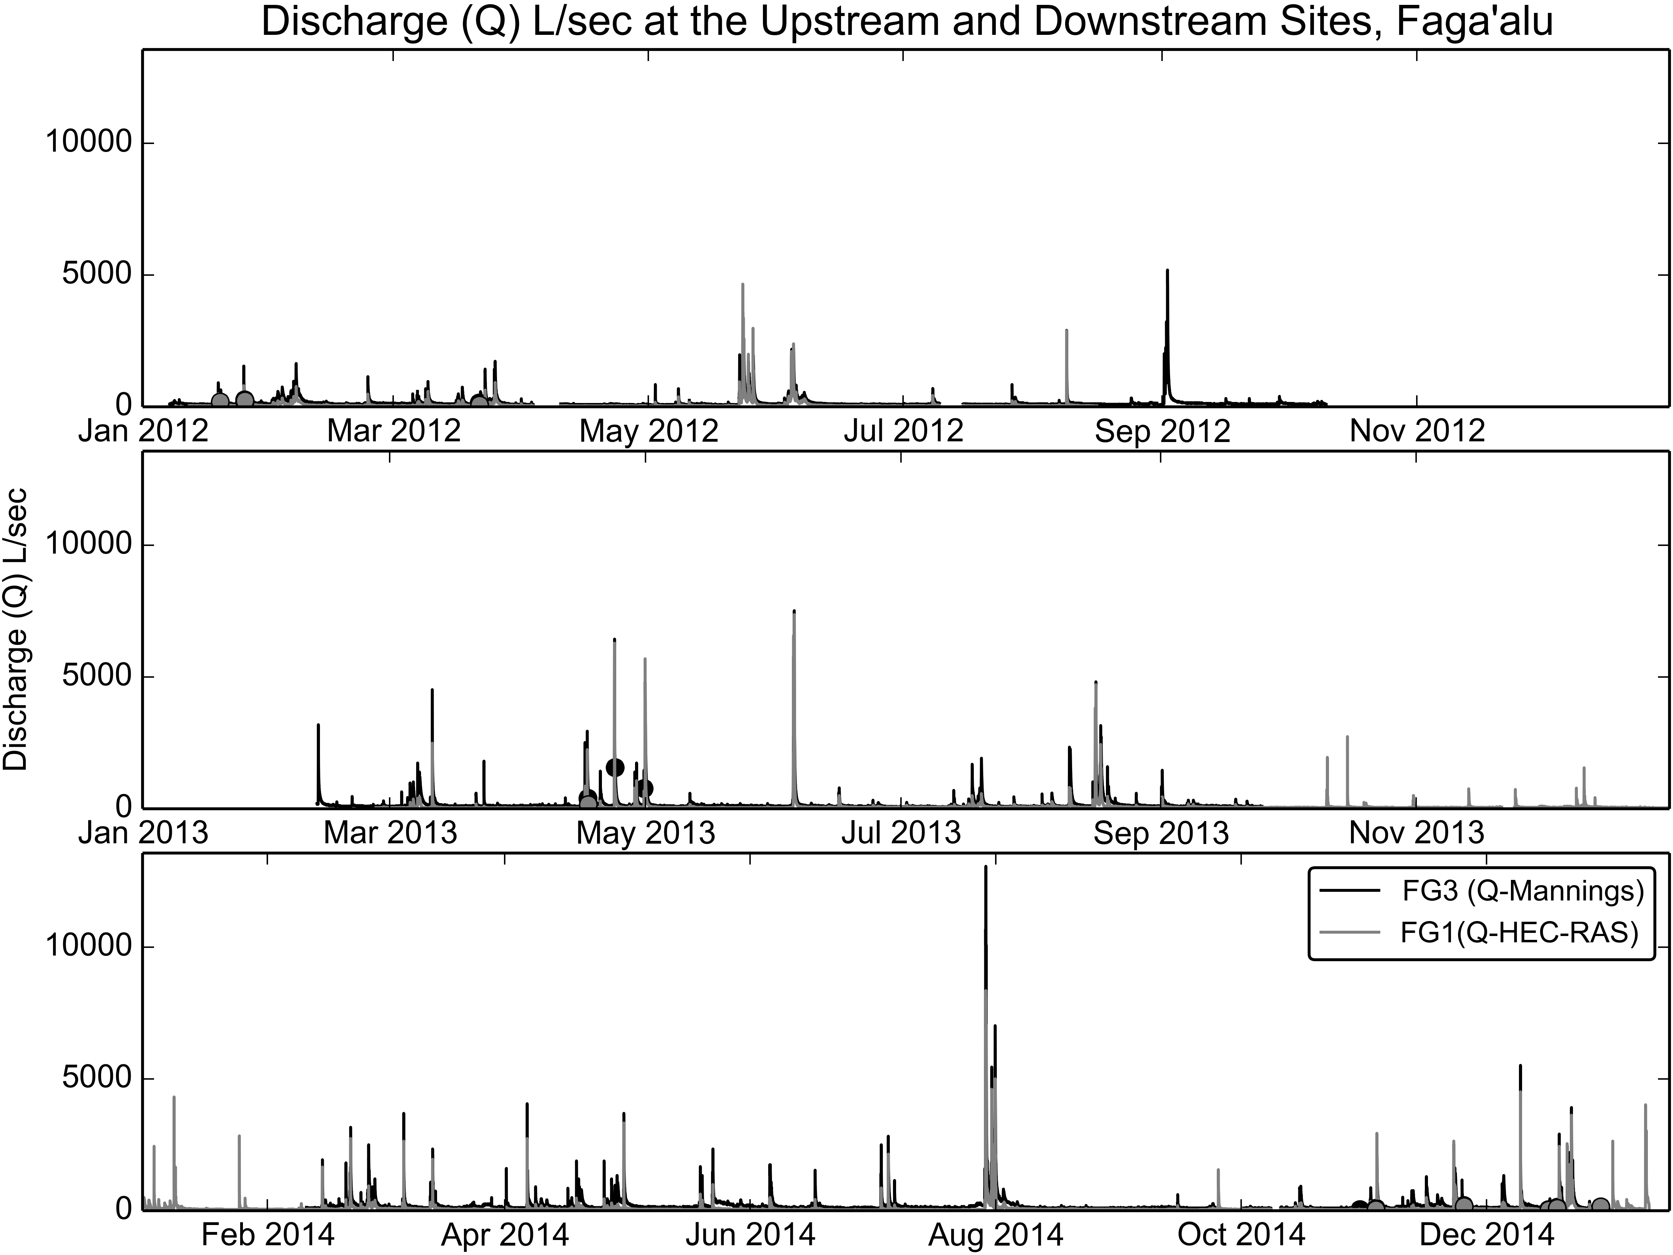

Figure 5. Time series of water discharge (Q), calculated from measured stage and the stage-discharge rating curves.

#### Storm Events

Most storm events showed a typical pattern, where a short period of intense rainfall caused a rapid increase in SSC downstream of the quarry (FG2) while SSC remained low at FG1, indicating rapid sheetwash of sediment from the quarry into the stream (Figure 6). Highest event SSC was typically observed at FG2, with slightly lower and later peak SSC observed at FG3. SSC at FG1 typically increased more slowly, remained much lower, and peaked later than the downstream sites (FG2 and FG3). Though peak SSC was highest at FG2, the total SSY was highest at FG3 due to the addition of storm runoff from the relatively larger watershed downstream. Storm flow at FG3 includes both storm runoff and sediment from disturbed areas of the quarry and village, and the undisturbed forest on the steep hillsides in the lower watershed. Complex storm events occurred when a subsequent period of rainfall followed before Q and SSC fell back to baseflow levels. Several complex events where Q peaks were separated by at least a two hour period of time and Q was nearly at baseflow were separated into individual storm events.

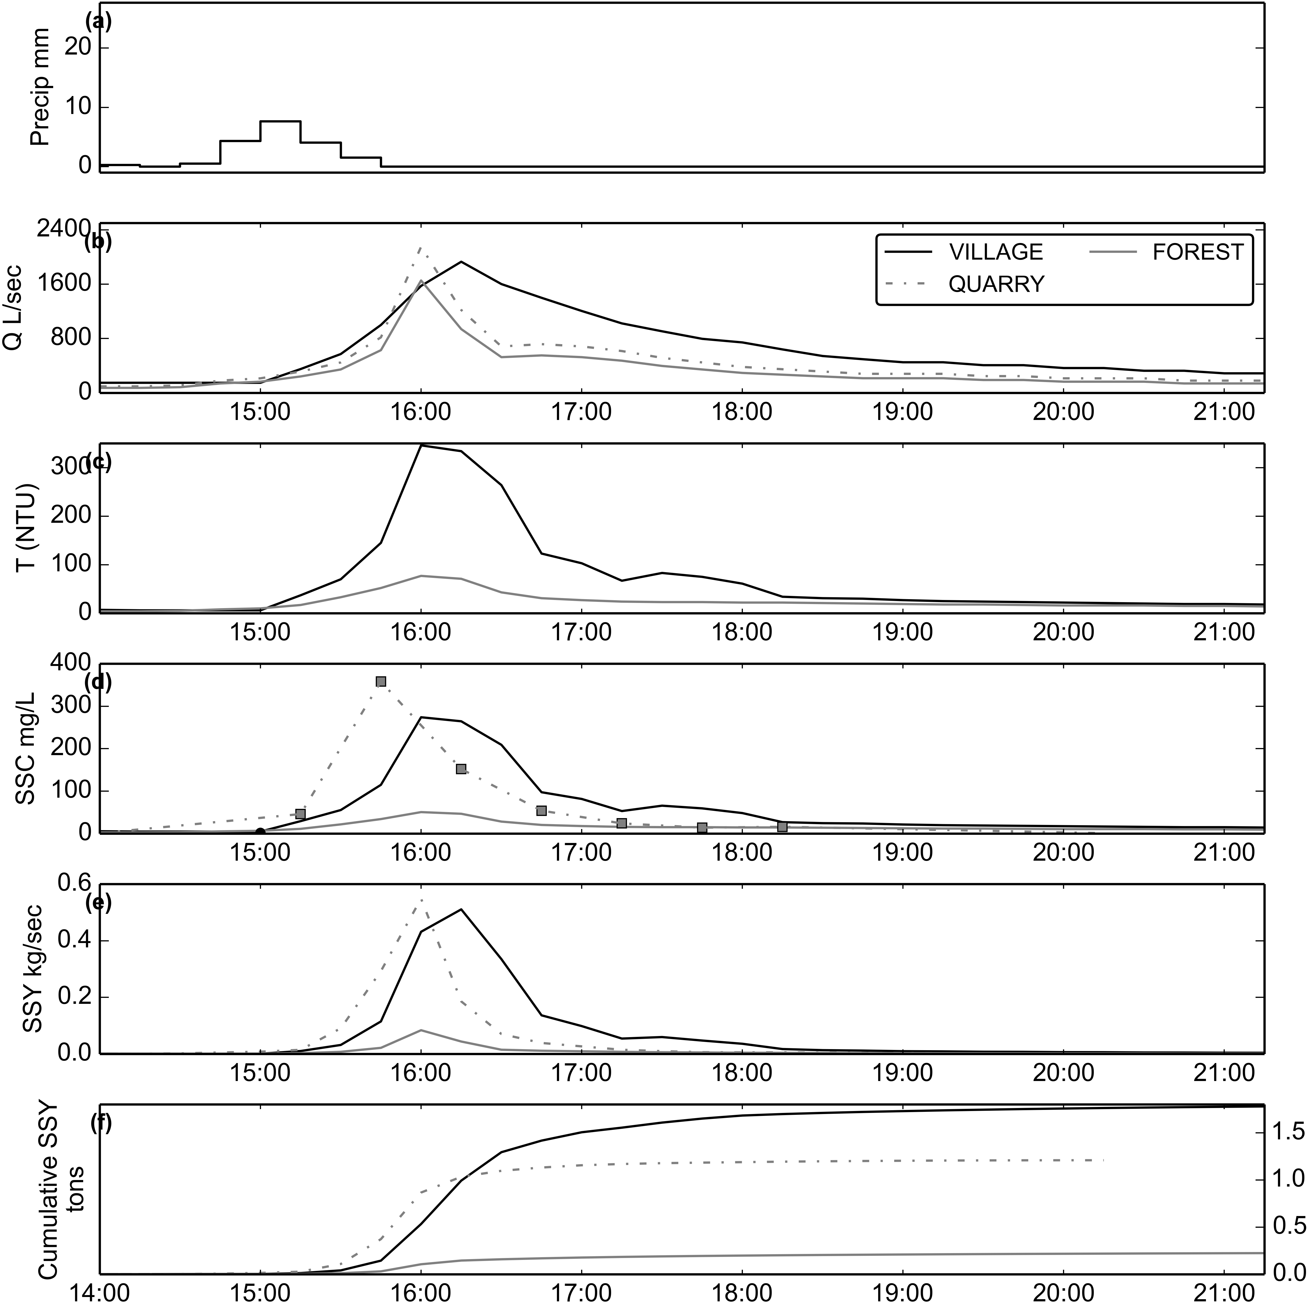

Figure 6. Example of storm event (02/14/2014). SSY at FOREST and VILLAGE calculated from SSC modeled from T, and SSY at QUARRY from SSC samples collected by the Autosampler.

Using the stage threshold method and manual separation of complex storm events, 99 storm events were identified from Q data at FG3 from January, 2012, to July 2014. Valid Q data was recorded during 97 events at FG1, and 99 events at FG3 (Appendix, Table 1). Valid SSC data from T and Interpolated Grab samples was recorded during 64 events at FG1, and 55 events at FG3. Of those storms, 37 events had valid P and SSY data for both the FG1 and FG3 to calculate and compare SSY from the UPPER and LOWER subwatersheds (Table 2). Valid SSY data from Interpolated grab samples was collected at FG2 for 8 storms to compare with SSY from FG1 and FG3 directly (Table 3). Storm event durations ranged from 2 hours to 5 days, with mean duration of 13 hours.

#### Suspended Sediment Concentration

From January 6, 2012, to October 1, 2014, 610 water samples were collected at 12 sites in Faga'alu and analyzed for SSC. Three sites were the focus of this analysis: 1) FG1 (n=55), 2) FG2 (n=91 grab samples, n=186 from the Autosampler), and 3) FG3 (n=154). Mean SSC of grab samples collected during baseflow and stormflow were lowest at the FG1 site (31 mg/L), and highest at FG2 (334 mg/L) and the downstream FG3 site (152 mg/L). Maximum SSC values were 500 mg/L, 12,600 mg/L, and 3,500 mg/L at the upstream (FG1), quarry (FG2), and downstream (FG3) sites, respectively. The maximum SSC values at FG2 (12,600 mg/L ) and FG3 (3,500 mg/L) were sampled during the same event (03/05/2012), during fairly low discharge (Q_FG3=287 L/sec). The maximum SSC value for the upstream site (500 mg/L) was sampled on 04/23/2013 at high discharge (Q_FG1= 3,724 L/sec). Anecdotal and field observations reported higher than normal SSC upstream of the quarry during the 2013 field season, possibly due to landsliding from large storms (G. Poysky, pers. comm.).

At FG1, 0% of grab samples (n=32) were taken during stormflow conditions (Q_FG1>165 L/sec), with mean SSC of 47 mg/L (Figure 7, and 0% of grab samples (n=23) were taken during baseflow conditions with a mean SSC of 9 mg/L (Figure 7(a)). At FG2, 0% of grab samples (n=46) were taken during stormflow conditions (Q_FG1>165 L/sec), with mean SSC of 200 mg/L, and 0% of grab samples (n=45) were taken during baseflow conditions, with mean SSC of 471 mg/L. At FG3, 0% of samples (n=89) were taken during stormflow conditions (Q_FG3>364 L/sec), with mean SSC of 145 mg/L, and 0% of samples (n=65) were taken during baseflow conditions, with mean SSC of 163 mg/L. This pattern of SSC values suggests that little sediment is contributed from the forest upstream of FG1, then there is a large input of sediment between FG1 and FG2, and then SSC is diluted by addition of stormflow with lower SSC between FG2 and FG3.

The highest SSC values were observed just downstream of the quarry (FG2), mainly during baseflow. Given the close proximity of the quarry to the stream, SSC downstream of the quarry can be highly influenced by mining activity like rock extraction, crushing or hauling operations. Also, during 2012 a common practice for removing fine sediment from crushed aggregate was to rinse it with water pumped from the stream. In the absence of retention structures the fine sediment was discharged directly into the stream, causing high SSC during low Q that was uncorrelated with storm events. While sheetwash erosion of the quarry during storm events causes higher SSY than during baseflow periods, the instantaneous SSC values during stormflows are lower due to dilution by water discharged from surrounding forest areas. The practice of manually rinsing fine sediment from aggregate was discontinued in 2013, corresponding with a lack of high SSC grab samples during low discharges (Figure 8). Stock and Tribble (2009): The Hanalei samples had an average suspended sediment concentration of 63 mg/L, with a maximum value of 2,750 mg/l (at an instantaneous flow of 14,100 cfs). The Kawela samples had an average suspended sediment concentration of 3,490 mg/L, with a maximum value of 54,000 mg/l (at an instantaneous flow of 57 cfs).

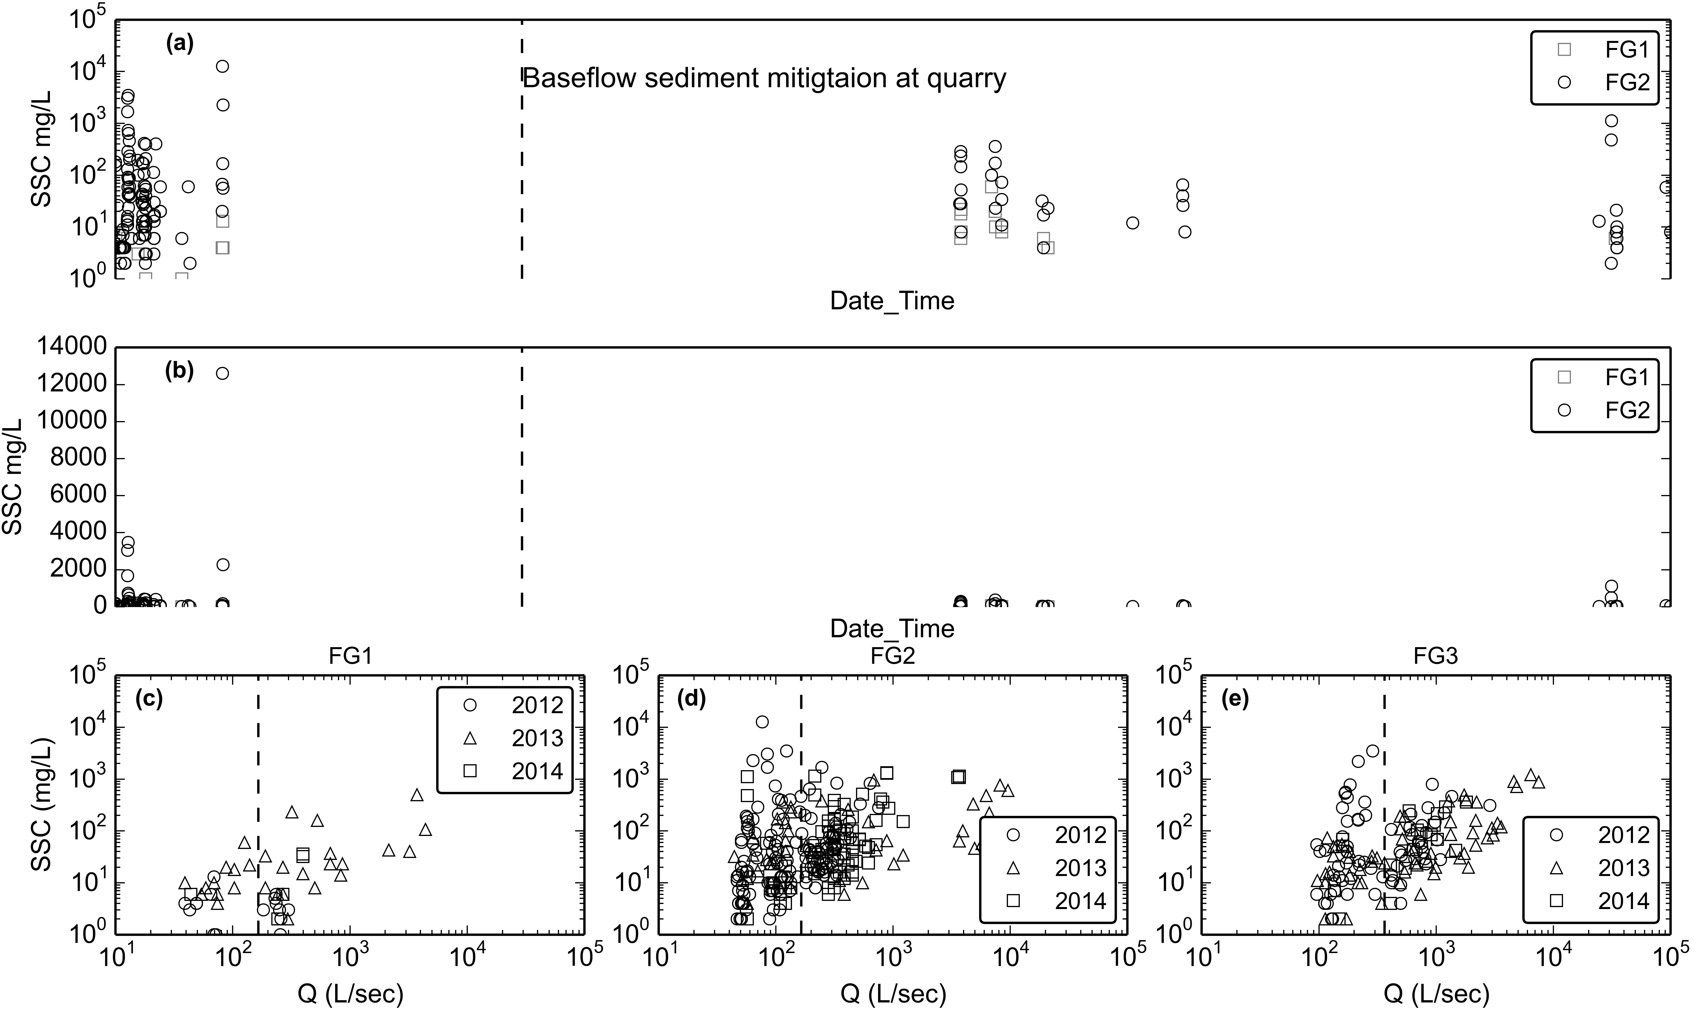

Figure 8. Water Discharge vs Suspended Sediment Concentration at FOREST, QUARRY, and VILLAGE during baseflow and stormflow periods. Samples from Autosampler are included with grab samples at QUARRY.

No clear relationship between Q and SSC could be determined for any of the three sites (FOREST, QUARRY, VILLAGE) due to significant hysteresis observed during storm periods, and the changing sediment availabilty associated with the quarrying operations. At FOREST, variability of SSC samples during stormflows from year to year was assumed to be caused by randomly occurring landslides caused by large storms.

#### Turbidity

A "synthetic" T-SSC relationship (SRC) was developed for the YSI 600OMS turbidimeter at FOREST and the CampbellSci OBS500 at VILLAGE, in 2014, using sediment collected from the streambed near the turbidimeter (Appendix Figure 3). These relationships were compared with the T-SSC relationships developed using in situ data collected under storm conditions (Figures 9-11). In all instances, the SRC's had a steeper slope than the T-SSC relationships from storm samples, suggesting that even though the sediment used to develop the SRC's was taken from nearby stream banks, it differed in character from the sediment collected under actual storm conditions. The T-SSC relationships under actual storm conditions all showed acceptable r2 values (0.86-0.97), so the SRC's were not used to model SSC from T data.

The T-SSC relationship varied among sampling sites and sensors. Lower scatter in the linear relationships was achieved by using grab samples collected during stormflows only. It is assumed that the color, particle sizes, and composition of sediment changes during stormflows when sediment from the quarry, which is lighter in color and finer, is present. For the TS3000 deployed at FOREST, the r2 value was fairly high (0.96) but the ranges of T and SSC values used to develop the relationship were considered too small to develop a robust relationship for higher T values. Instead, the T-SSC relationship developed for the YSI turbidimeter installed at FOREST (Figure 9) was used to convert T data from the TS3000 to SSC. For the YSI 600OMS turbidimeter, more scatter was observed in the T-SSC relationship at VILLAGE than at FOREST (Figure 9), but this could be attributed to the higher number and wider range of values sampled, as well the contribution of multiple sediment sources sampled at VILLAGE.

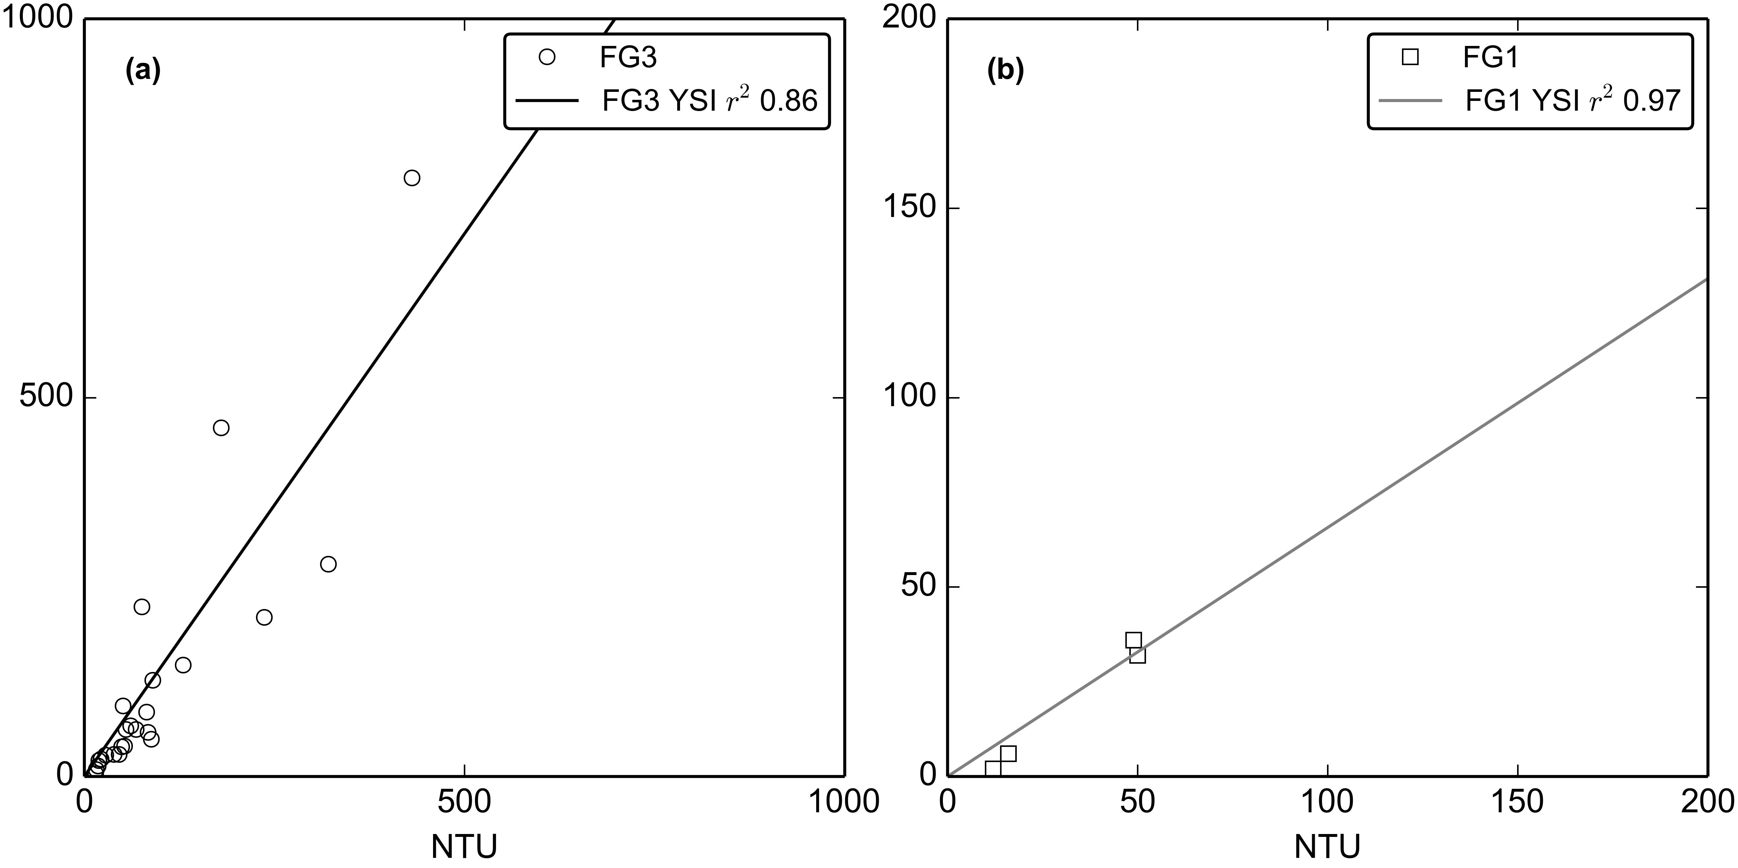

Figure 9. Turbidity-Suspended Sediment Concentration relationships for (a) the YSI turbidimeter deployed at FG3 (02/27/2012-05/23/2012) and (b) the YSI turbidimeter deployed at FG1 (06/13/2013-12/31/2014).

The CampbellSci OBS500 measures both BS and SS, and both the BS-SSC and SS-SSC relationships at VILLAGE showed high r2 values (Figure 10 and Figure 11). Mean SS was used since it is physically measured the same as NTU measured by the YSI turbidimeter (Chauncey W. Anderson 2005).

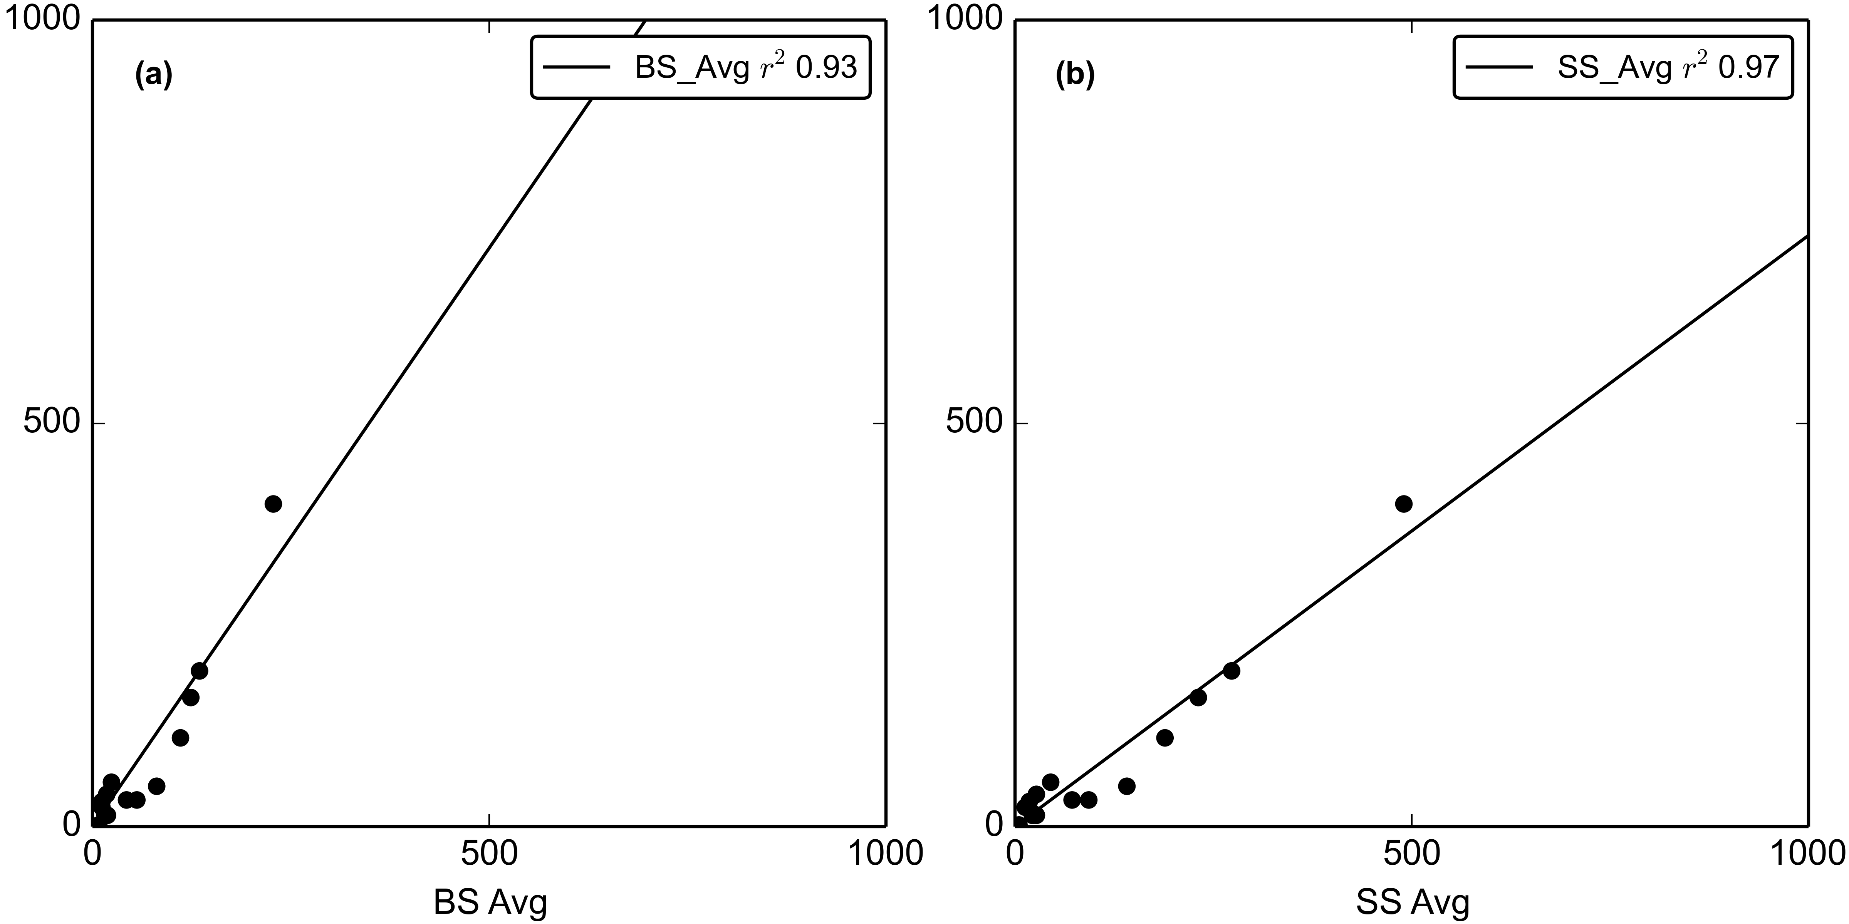

Figure 10. Turbidity-Suspended Sediment Concentration relationships for the OBS500 turbidimeter deployed at VILLAGE (03/11/2013-07/15/2013).

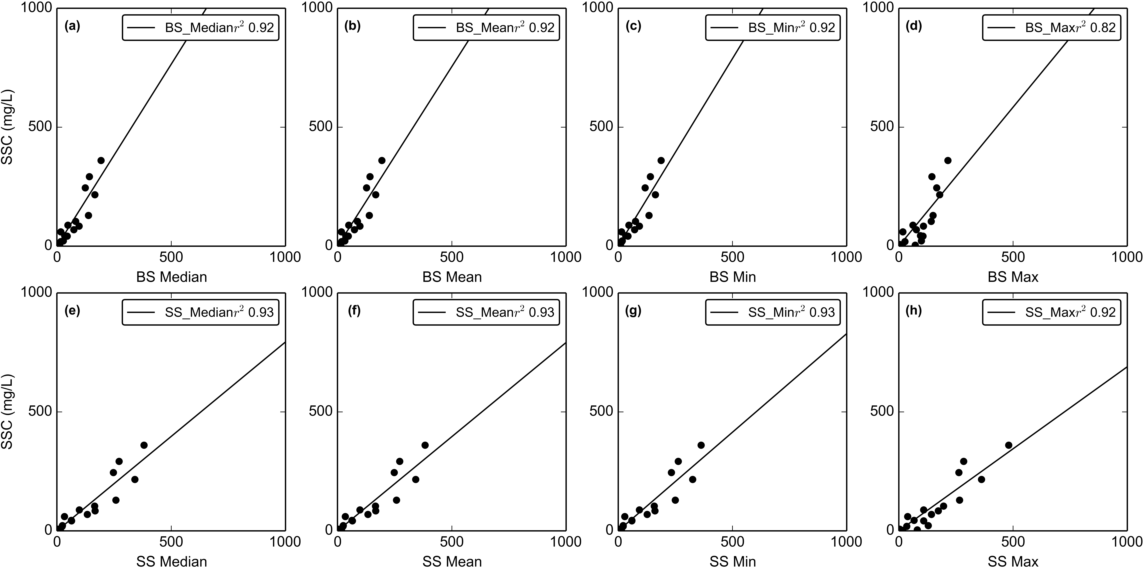

Figure 11. Turbidity-Suspended Sediment Concentration relationships for the OBS500 turbidimeter deployed at VILLAGE (01/31/2014-03/04/2014).

### Probable Error estimates for SSY

Probable Error (%) was calculated by equation 5 to estimate the uncertainty in SSYEV resulting from measurement and model errors (Harmel et al., 2006). The RMSE for each selected T-SSC relationship was computed and used in the estimate of Probable Error. The RMSE for the T-SSC relationship was 5, 82, 25, 40 mg/L for the YSI at FOREST, YSI at VILLAGE, CampbellSci OBS500 at VILLAGE (2013), and CampbellSci OBS500 at VILLAGE (2014), respectively. The RMSE for YSI at FOREST was also used for the TS3000 at FOREST since the same T-SSC relationship was used.

### Comparing SSY from disturbed and undisturbed subwatersheds

A main objective for this study was to determine how much human disturbance has increased Total SSY to Faga'alu Bay (SSYTOTAL). Two approaches were used to determine relative contributions to SSYTOTAL from the undisturbed and human-disturbed areas: comparing individual event and average percent contributions, and the Disturbance Ratio (DR)(Eq. 2). SSYTOTAL was measured at FG3, SSY from the UPPER subwatershed (SSYUPPER) was measured at FG1, and SSY from the LOWER subwatershed (SSYLOWER) was calculated by subtracting SSYUPPER from SSYTOTAL (SSYLOWER = SSYFG3 - SSYFG1) (Table 2).

|  |  |  |  |  |  |  |  |  |  |  |  |
| --- | --- | --- | --- | --- | --- | --- | --- | --- | --- | --- | --- |
| Table 2. Sediment yield from subwatersheds in Faga'alu | | | | | | | | | | | |
| Storm Start | Storm# | Precip (mm) | UPPER tons | UPPER SSY data source | UPPER PE % | LOWER tons | TOTAL tons | TOTAL SSY data source | TOTAL PE % | % UPPER | % LOWER |
| 02/02/2012 | 1 | 16 | 0.05 | T | 29 | 0.82 | 0.87 | T | 74 | 5.0 | 94.0 |
| 02/03/2012 | 2 | 24 | 0.08 | T | 29 | 1.82 | 1.9 | T | 74 | 4.0 | 95.0 |
| 02/05/2012 | 3 | 19 | 0.05 | T | 29 | 0.76 | 0.81 | T | 74 | 6.0 | 93.0 |
| 02/05/2012 | 4 | 83 | 0.44 | T | 29 | 6.54 | 6.98 | T | 74 | 6.0 | 93.0 |
| 03/08/2012 | 5 | 23 | 0.06 | T | 29 | 2.28 | 2.34 | T | 74 | 2.0 | 97.0 |
| 03/09/2012 | 6 | 18 | 0.17 | T | 29 | 2.0 | 2.16 | T | 74 | 7.0 | 92.0 |
| 03/16/2012 | 7 | 22 | 0.05 | T | 29 | 1.2 | 1.25 | T | 74 | 3.0 | 96.0 |
| 03/17/2012 | 8 | 30 | 0.07 | T | 29 | 2.37 | 2.44 | T | 74 | 2.0 | 97.0 |
| 03/21/2012 | 9 | 14 | 0.14 | T | 29 | 1.01 | 1.15 | T | 74 | 12.0 | 87.0 |
| 03/22/2012 | 10 | 35 | 0.33 | T | 29 | 4.35 | 4.67 | T | 74 | 7.0 | 92.0 |
| 03/25/2012 | 11 | 49 | 0.63 | T | 29 | 7.66 | 8.29 | T | 74 | 7.0 | 92.0 |
| 05/02/2012 | 12 | 30 | 0.02 | T | 29 | 3.45 | 3.46 | T | 74 | 0.0 | 99.0 |
| 05/08/2012 | 13 | 25 | 0.1 | T | 29 | 2.84 | 2.94 | T | 74 | 3.0 | 96.0 |
| 05/22/2012 | 14 | 33 | 0.47 | T | 29 | 6.12 | 6.59 | T | 74 | 7.0 | 92.0 |
| 03/06/2013 | 15 | 21 | 0.06 | g | 26 | 0.85 | 0.9 | g | 35 | 6.0 | 93.0 |
| 04/16/2013 | 16 | 53 | 0.53 | g | 26 | 3.88 | 4.41 | g | 35 | 12.0 | 87.0 |
| 04/23/2013 | 17 | 83 | 9.55 | g | 26 | 16.86 | 26.41 | g | 35 | 36.0 | 63.0 |
| 04/30/2013 | 18 | 112 | 0.48 | g | 26 | 7.57 | 8.05 | g | 35 | 5.0 | 94.0 |
| 06/05/2013 | 19 | 170 | 4.69 | g | 26 | 34.73 | 39.42 | g | 35 | 11.0 | 88.0 |
| 06/16/2013 | 20 | 28 | 0.13 | T | 36 | 0.42 | 0.55 | T | 38 | 23.0 | 76.0 |
| 02/14/2014 | 21 | 18 | 0.22 | T | 36 | 1.54 | 1.76 | T | 52 | 12.0 | 87.0 |
| 02/15/2014 | 22 | 11 | 0.02 | T | 36 | 0.5 | 0.52 | T | 52 | 3.0 | 96.0 |
| 02/18/2014 | 23 | 11 | 0.0 | T | 36 | 0.09 | 0.09 | T | 52 | 1.0 | 98.0 |
| 02/20/2014 | 24 | 29 | 0.12 | T | 36 | 3.65 | 3.76 | T | 52 | 3.0 | 96.0 |
| 02/21/2014 | 25 | 51 | 1.84 | T | 36 | 7.71 | 9.56 | T | 52 | 19.0 | 80.0 |
| 02/24/2014 | 26 | 20 | 0.06 | T | 36 | 0.44 | 0.5 | T | 52 | 12.0 | 87.0 |
| 02/25/2014 | 27 | 60 | 0.53 | T | 36 | 6.96 | 7.49 | T | 52 | 7.0 | 92.0 |
| 02/27/2014 | 28 | 35 | 0.24 | T | 36 | 1.94 | 2.17 | T | 52 | 10.0 | 89.0 |
| Total/Avg: | 28 | 1123 | 21.1 |  | 31 | 130.4 | 151.4 |  | 59 | 14 | 86 |
| Tons/km2 |  |  | 23.5 |  |  | 148.1 | 85.1 |  |  | - | - |
| sSSY:sSSY_UPPER |  |  | 1 |  |  | 6.3 | 3.6 |  |  | - | - |
| fraction disturbed (%) |  |  | 0.4 |  |  | 5.2 | 6.8 |  |  | - | - |
| SSY from forested areas (tons) |  |  | 21 |  |  | 20 | 39 |  |  | - | - |
| SSY from disturbed areas (tons) |  |  | 0.1 |  |  | 110.8 | 112.5 |  |  | - | - |
| % SSY from disturbed areas |  |  | 0.4 |  |  | 85 | 74 |  |  | - | - |
| sSSY from disturbed areas (tons/km2) |  |  | 23.5 |  |  | 2420.8 | 929.4 |  |  | - | - |
| DR for sSSY from disturbed areas |  |  | - |  |  | 103 | 40 |  |  | - | - |

The UPPER and LOWER subwatersheds are similar in size (0.90 km2 and 0.87 km2) so assuming the specific SSY (sSSY (tons/km2)) is similar in both watersheds under pre-disturbance conditions, they should account for roughly the same percentage contribution to SSYTOTAL. However, for the 37 storms with valid data from both FG1 and FG3, SSYUPPER accounted for 0.0-36%, average of 14% of SSYTOTAL. SSYLOWER accounted for 63-99%, average of 86% of SSYTOTAL (Table 2). Total SSY from the UPPER and LOWER subwatersheds for the measured storms was 21.1 and 130.4 (tons), respectively, and corresponding sSSY was 23.5 and 148.1 (tons/km2), respectively. Comparing sSSY from the undisturbed UPPER watershed and the disturbed LOWER watershed shows sSSY has been increased by 6.3x in the LOWER subwatershed, and 3.6x for the TOTAL watershed.

The measured sSSY from the undisturbed UPPER watershed (23.5 tons/km2) was used to estimate SSY from undisturbed areas in the LOWER subwatershed (20 tons), and estimate SSY from the 0.045 km2 of disturbed areas in the LOWER subwatershed (110.8 tons). For the measured storms, roughly 85% of SSY from the LOWER subwatershed is from disturbed areas, despite the disturbed areas only accounting for 5.2% of the subwatershed area. Similarly, despite only 6.8% of the TOTAL watershed being disturbed, SSY from disturbed areas accounts for 74% of the SSY from the TOTAL watershed. The sSSY from disturbed areas is the same as sSSY from the whole UPPER subwatershed since the disturbed areas cover such a small fraction, their influence is not detected. Estimated sSSY from disturbed areas in the LOWER subwatershed is 2420.8 tons/km2, suggesting human disturbance has increased sSSY by 103x over undisturbed, forest conditions.

SSYEV data measured at FG2 was available for 8 of the storms in Table 2, so SSYEV from the LOWER subwatershed including the quarry (SSYLOWER_QUARRY) and the village areas below the quarry (SSYLOWER_VILLAGE) could be calculated to determine the relative sediment contribution from these sources. SSY from the subwatershed including the quarry (SSYLOWER_QUARRY) was calculated as SSYLOWER_QUARRY=SSYFG2-SSYFG1. SSY from the subwatershed below the quarry, including the village (SSYLOWER_VILLAGE) was calculated as SSYLOWER_VILLAGE = SSYFG3 - SSYFG2 (Table 3).

|  |  |  |  |  |  |  |  |  |  |
| --- | --- | --- | --- | --- | --- | --- | --- | --- | --- |
| Table 3. Sediment yield from subwatersheds in Faga'alu | | | | | | | | | |
| Storm Start | Storm# | Precip (mm) | UPPER tons | LOWER_QUARRY tons | LOWER_VILLAGE tons | TOTAL tons | % UPPER | % LOWER_QUARRY | % LOWER_VILLAGE |
| 03/06/2013 | 1 | 21 | 0.06 | 0.23 | 0.61 | 0.9 | 6.0 | 25.0 | 67.0 |
| 04/16/2013 | 2 | 53 | 0.53 | 3.49 | 0.39 | 4.41 | 12.0 | 79.0 | 8.0 |
| 04/23/2013 | 3 | 83 | 9.55 | 7.06 | 9.8 | 26.41 | 36.0 | 26.0 | 37.0 |
| 04/30/2013 | 4 | 112 | 0.48 | 0.68 | 6.89 | 8.05 | 5.0 | 8.0 | 85.0 |
| 06/05/2013 | 5 | 170 | 4.69 | 30.6 | 4.13 | 39.42 | 11.0 | 77.0 | 10.0 |
| 02/14/2014 | 6 | 18 | 0.22 | 0.98 | 0.56 | 1.76 | 12.0 | 55.0 | 31.0 |
| 02/20/2014 | 7 | 29 | 0.12 | 1.14 | 2.5 | 3.76 | 3.0 | 30.0 | 66.0 |
| 02/21/2014 | 8 | 51 | 1.84 | 3.91 | 3.81 | 9.56 | 19.0 | 40.0 | 39.0 |
| Total/Avg: | 8 | 537 | 17 | 48 | 29 | 94 | 19 | 51 | 30 |
| Tons/km2 |  |  | 19 | 178 | 47 | 53 | - | - | - |
| sSSY:sSSY_UPPER |  |  | 1.0 | 9.17 | 2.4 | 2.7 | - | - | - |
| fraction disturbed (%) |  |  | 0.4 | 6.5 | 4.9 | 6.8 | - | - | - |
| SSY from forested areas (tons) |  |  | 17.4 | 4.9 | 11.3 | 32.2 | - | - | - |
| SSY from disturbed areas (tons) |  |  | 0.1 | 43.18 | 17.4 | 62.0 | - | - | - |
| % SSY from disturbed areas |  |  | 0.4 | 90 | 61 | 66 | - | - | - |
| sSSY from disturbed areas (tons/km2) |  |  | 19.4 | 2460.6 | 582.7 | 512.5 | - | - | - |
| DR for sSSY from disturbed areas |  |  |  | 126.6 | 30.0 | 26.4 | - | - | - |

For the measured storms, TOTAL SSY was 94 tons, comprised of an average of 19% from the UPPER subwatershed, 51% from LOWER_QUARRY subwatershed, and 30% from the LOWER_VILLAGE subwatershed. sSSY from the UPPER, LOWER_QUARRY, and LOWER_VILLAGE subwatersheds and TOTAL watershed was 19, 178, 47, and 53, respectively. sSSY from LOWER_QUARRY and LOWER_VILLAGE was 9.17 and 2.4 times higher, respectively, than sSSY from UPPER subwatershed, suggesting human disturbance has significantly increased SSY over natural levels, particularly at the quarry. sSSY from the TOTAL watershed was 2.7 times higher than the UPPER subwatershed, similar to the larger range of storms in Table 2, where specific SSY was 3.6 times higher.

The measured sSSY from the undisturbed UPPER watershed (19 tons/km2) was used to estimate SSY from undisturbed areas in the LOWER_QUARRY and LOWER_VILLAGE subwatersheds: 4.9 and 11.3 tons, respectively. SSY from the 0.018 km2 and 0.029 km2 of disturbed areas in the LOWER_QUARRY and LOWER_VILLAGE subwatersheds was 43.18 and 17.4 tons, respectively. SSY from the disturbed areas accounted for 90% and 61% of total SSY from those watersheds, respectively. sSSY from disturbed areas in the UPPER, LOWER_QUARRY, and LOWER_VILLAGE subwatersheds was 19.4, 2460.6, and 582.7, respectively, suggesting that disturbed areas increase sSSY over forested conditions by 126.6x and 30.0x in the LOWER_QUARRY and LOWER_VILLAGE subwatersheds, respectively. Disturbed area includes both urbanized (impervious) and bare land fractions, though most disturbed area in the LOWER_VILLAGE watershed is attributed to urbanized areas, and most disturbed area in LOWER_QUARRY is attributed to bare land, causing the large difference in sSSY from disturbed areas in these subwatersheds.

For the measured storms, roughly 90% and 61% of SSY from the LOWER_QUARRY and LOWER_VILLAGE subwatersheds, respectively, is from disturbed areas, despite the disturbed areas only accounting for 6.5% and 4.9% of the subwatershed area, respectively. Similarly, despite only 6.8% of the TOTAL watershed being disturbed, SSY from disturbed areas accounts for 90% of the SSY from the TOTAL watershed.

Annual estimates of SSY and sSSY are most commonly used to compare watersheds, however, a continuous annual time-series of SSY was not possible at the study site due to the discontinuous field sampling trips. For storms totaling 537 mm of precipitation meausured in Table 2, SSY from the UPPER and LOWER subwatersheds was 17 and 130.4 tons, respectively, and sSSY from the UPPER and LOWER subwatersheds was 19 and 148.1 tons/km2, respectively. Annual precipitation is roughly 3-4 times the precipitation measured during storms (on the order of 4,000 mm), so annual SSY and sSSY are estimated to be roughly 3-4 times the measured SSY and sSSY: 60-80 tons/year, and 70-90 tons/km2/year for the UPPER subwatershed, and 390-520 tons/year, and 440-590 tons/km2/year for the UPPER subwatershed. SSY and sSSY from the TOTAL watershed was 94 tons and 53 tons/km2, respectively, so annual SSY and sSSY are estimated to be 450-610 tons/year, and 260-340 tons/km2/year.

For the storms totaling 537 mm of precipitation measured in Table 3, SSY from the UPPER, LOWER_QUARRY, and LOWER_VILLAGE subwatersheds was 17, 48, and 29 tons, respectively, and sSSY from the UPPER, LOWER_QUARRY, and LOWER_VILLAGE subwatersheds was 19, 178, and 47 tons/km2, respectively. Annual precipitation is roughly 6-8 times the precipitation measured for these storms (on the order of 4,000 mm), so annual SSY and sSSY are estimated to be roughly 6-8 times the measured SSY and sSSY. Annual SSY from the UPPER, LOWER_QUARRY, and LOWER_VILLAGE subwatersheds was estimated to be 100-140, 290-380, and 170-230 tons/year, respectively. Annual sSSY from the UPPER, LOWER_QUARRY, and LOWER_VILLAGE subwatersheds was estimated to be 110-150, 1070-1420, and 280-380 tons/km2/year, respectively. SSY and sSSY from the TOTAL watershed was 94 tons and 53 tons/km2, respectively, so annual SSY and sSSY are estimated to be 560-750 tons/year, and 320-420 tons/km2/year. sSSY from the disturbed fraction (6.5%) of the LOWER_QUARRY subwatershed (0.27 km2) was 2460.6 tons/km2 for the 537 mm of precipitation during the measured storms (roughly 12-15% of annual precipitation). Annual precipitation is on the order of 4,000 mm, so annual specific SSY is roughly 6-8 times the measured specific SSY, approximately 14800-19700 tons/km2/year. Ramos-Scharron (2005) tabulated sSSY rates for cut-slopes, finding........

Only storms with SSY data at both FG1 and FG3, and at FG1, FG2 and FG3 are presented in Tables 2 and 3. Using all SSY data measured at FG1 (SSYUPPER), SSY for 70% of annual precipitation (2780 mm) of precipitation (~4,000 mm) were measured. Storm data for Table 2 and 3 Annual SSY from the UPPER subwatershed was estimated from Table 2 and Table 3 to be 60-80 and 100-140, respectively.

Data in Milliman and Syvitski (1992) suggests there is unusually high average sSSY for watersheds (10-100,000km2) on high-standing, South Pacific Islands on the order of 1,000-3,000 tons/km2/year, however, they acknowledge the role of sediment erodibility and effects of geology, vegetation cover and human activity. Given the high vegetation cover and lack of human activity in the UPPER subwatershed, it is assumed that specific SSY should be several orders of magnitude lower than watersheds presented in Milliman and Syvitski (1992). Models to estimate sSSY from basin area and maximum elevation in Oceania (Milliman and Syvitski, 1992) predicts 13 tons/km2/year for watersheds 500-1,000m and 68 tons/km2/year for max elevations of 1,000-3,000 m. SSY and sSSY from the UPPER subwatershed is higher than predicted by Milliman and Syvitski's (1992) model but it is also a smaller watershed than they included in their analysis, and high scatter above their model is observed for smaller watersheds in their Figures 5e and 6e. In Hanalei watershed, a larger watershed (54 km2) which has similarly steep relief and high rainfall (2,000-11,000 mm), Calhoun and Fletcher (1999) and Stock and Tribble (2010) estimated sSSY was 140 plus-minus55 tons/km2/year and 525 tons/km2/yr, respectively. In Kawela watershed (14 km2), a similaryly disturbed, sub-humid watershed (500-3,000 mm precipitation) on Molokai, Stock and Tribble estimated sSSY was 459 tons/km2/yr.

The DR is the ratio of SSY from the total watershed under current human-disturbed conditions to SSY under pre-disturbance conditions (SSYPRE)(Equation 2). This assumes that prior to humans altering the land cover the whole watershed was covered in forest, and the specific SSY of the whole watershed (tons/km2) was the same as the forest area currently covering the Upper subwatershed. The specific SSY for both FOREST and VILLAGE were calculated by summing all storms from Table 2 and dividing by the subwatershed area. The DR for SSY was 3.6, meaning human disturbance has increased Total SSY 3.6x over undisturbed levels.

The DR for specific water discharge (Q) was also calculated to determine if observed changes in SSY were attributable to errors in quantifying Q, and if urbanization and agriculture has affected the total water discharge from the watershed. The DR for water discharge was 1.0, suggesting that specific water discharge from the subwatersheds is the same, which is expected since they are similar sizes. Urbanization has likely increased water discharge, since the relatively large amounts of impervious surface in the village area increase runoff. However, the village area occupies a small percentage (3.6%) of the LOWER subwatershed area in comparison to the forest area (84.5) (Table 1), and the relatively small increase in Q could be within the acceptable measurement error for quantifying Q.

|  |  |  |
| --- | --- | --- |
| Table 4. Total Q and SSY | | |
| 0 | 1 | 2 |
| Storms | 28 |  |
| Precipitation (mm) | 1137 |  |
| subwatershed | UPPER | LOWER |
| Q (MCM) | 0.53 | 1.01 |
| Q (mm) | 592 | 566 |
| Q Disturbance Ratio | - | 1.0 |
| SSY (Mg) | 21.1 | 151.5 |
| Spec SSY (Mg/km2) | 23.5 | 85.1 |
| SSY Disturbance Ratio | - | 3.6 |

Other studies have documented SSY increases of similar magnitude from small disturbances in small, mountainous watersheds. On Molokai, Stock et al. (2010) found that less than 5% of the land produces most of the sediment, and of that 5%, only 1% produces ~50% of the sediment. In three basins on St.John with varying levels of development, Ramos-Scharron et al (2005) found unpaved roads increased sediment delivery rates by 3-6 times for Lameshur Bay, 5-9 times for Fish Bay, and 4-8 times for Cinnamon Bay. Disturbances at large scales have had similar increases in total SSY to coral environments. The development of the Great Barrier Reef (GBR) catchment since European settlement (ca.1830) led to increases in SSY by an estimated factor of 5.5 (Kroon et al.,2012).

Stock and Tribble (2009): The two watersheds differ dramatically in the amount and timing of suspended sediment load. In Kawela, the average monthly load was 450 tons (Fig. 4, top), and the largest daily load was 4,310 tons. 50% of the load was transported on 0.3% of the days, and 90% of the load was transported on 1.0% of the days. Normalized to the drainage area of the watershed, average annual load was 1,020 tons/mi2. In Hanalei, the average monthly load was 2,120 tons (Fig. 4, bottom), and the largest daily load was 14,000 tons. 50% of the load was transported on 0.5% of the days, and 90% of the load was transported on 5.1% of the days. Normalized to the drainage area of the watershed, average annual load was 1,361 tons/mi2. This annual load represents 10% of the estimated Late Holocene sediment in the Hanalei floodplain (Calhoun & Fletcher, 1999), which would take ~ 400 years to form at current supply rates. Given a saprolite bulk density of 1,200 kg/m3, the average annual suspended load at Hanalei represents a basin-wide lowering rate of 0.44 mm/a, and that of Kawela a rate of 0.33 mm/a. For soil bulk densities of 950 kg/m3, Hanalei. Given a saprolite bulk density of 1,200 kg/m3, the average annual suspended load at Hanalei represents a basin-wide lowering rate of 0.44 mm/a, and that of Kawela a rate of 0.33 mm/a. For soil bulk densities of 950 kg/m3, Hanalei basin surface lowering is 0.56 mm/a, and that of Kawela basin is 0.42.

### Predicting SSYEV from storm metrics

The other main objectives for this analysis were to determine which storm metric is the best predictor of SSYEV, and use those storm-metric/SSYEV relationships to investigate if human sediment disturbance changes with storm size. Four storm metrics were assessed for predicting SSYEV: Total Precipitation (Psum), Erosivity Index (EI30), Total Water Discharge (Qsum), and Maximum Water Discharge (Qmax). Ordinary Least Squares regressions were fit to log-transformed storm metric data and specific SSYEV from the Upper and Total watersheds, measured at FOREST and VILLAGE respectively (Figure 12). Significant scatter was observed for all models, which reflects the changing sediment availability and natural variability in the watershed response for different storm events. In all models, specific SSYEV from the Total watershed was higher than the Upper watershed for the full range of measured storms with the exception of a few events that are considered outliers. These events could be attributed to measurement error but are likely related to landsliding events in the upper watershed and the increased sediment supply for that specific event. Storm sequence and antecedent conditions may also play a role. While the climate on Tutuila is tropical, without strong seasonality, periods of low rainfall can persist for several weeks, altering the water and sediment dynamics in the subsequent storm events.



Figure 12. SSY rating curves for predictors. Each point represents a different storm event.

Pearson and Spearman correlation coefficients were calculated to determine which storm metric was the best predictor of SSYEV (Table 5). Overall, statistically significant Pearson's and Spearman's correlation coefficients were fairly similar, meaning the relationships were mostly linear in log-log space. The exceptions were significantly higher Spearman's correlation coefficients for Psum for the Total watershed (Pearson's: 0.80 vs. Spearman's: 0.80) and Qmax for the Upper watershed (Pearson's: 0.89 vs. Spearman's: 0.94). Only EI30 had a higher Pearson's correlation coefficient than Spearman's, but both were low (Pearson's: 0.72 vs. Spearman's: 0.58).

Precipitation metrics (Psum and EI30) showed lower Pearson and Spearman correlation coefficients with SSYEV compared to the discharge metrics (Qsum and Qmax) over the full range of storm sizes. SSYEV is calculated from measured Q so it is expected that discharge metrics are more closely correlated, and has been observed in other studies (Rankl, Duvert etc.). The lowest correlation coefficients were observed for precipitation metrics, especially EI30 which was the least correlated of the storm metrics. No statistically significant correlations (p<0.001) were found between SSY and EI30 for the Upper watershed using Pearson's or Spearman's coefficients, and the statistically significant correlations between SSY and EI30 for the total watershed were the lowest of all storm metrics. Duvert et al. (2012) also found low correlation coefficients with 5 min rainfall intensity for 8 watersheds in France and Mexico. Rodrigues et al. (2013) hypothesized that EI30 is poorly correlated with SSY due to the effect of previous events on antecedent moisture conditions and in-channel sediment storage. Similar to other studies (Duvert et al., 2012; Rodrigues, Basher, Fahey, Rankl CITATION) the highest correlations were observed for discharge metrics, particularly Qmax which had the highest overall correlation with a Spearman correlation coefficient of 0.94 for the Upper watershed and 0.89 for the Total watershed.

|  |  |  |  |  |  |  |
| --- | --- | --- | --- | --- | --- | --- |
| Table 5. Model statistics | | | | | | |
| Model | Pearson | Spearman | r2 | RMSE(tons) | alpha | Beta |
| Psum_upper | 0.80 | 0.80 | 0.64 | 2.85 | 0.000 | 1.95 |
| Psum_total | 0.83 | 0.86 | 0.69 | 2.36 | 0.041 | 1.26 |
| EI_upper | - | - | 0.14 | 5.40 | 0.002 | 0.82 |
| EI_total | 0.72 | 0.58 | 0.51 | 3.41 | 0.002 | 1.32 |
| Qsum_upper | 0.89 | 0.89 | 0.79 | 2.26 | 0.000 | 1.17 |
| Qsum_total | 0.83 | 0.82 | 0.69 | 2.64 | 0.000 | 1.13 |
| Qmax_upper | 0.89 | 0.94 | 0.79 | 2.25 | 0.353 | 1.44 |
| Qmax_total | 0.89 | 0.89 | 0.79 | 2.22 | 1.380 | 1.81 |

The correlation coefficients for precipitation and discharge metrics are more similar for the Total watershed than for the Upper watershed. For the Total watershed, correlation coefficients for Psum are nearly equal to those for Qsum. However, for the Upper watershed, the discharge metrics show much higher Pearson and Spearman correlation coefficients than the precipitation metrics (Spearman's for Qsum: 0.89 vs. Psum: 0.80). This suggests that sediment production processes are more related to discharge processes in the Upper watershed, and more related to precipitation processes in the Lower watershed, influencing the correlation coefficients for the Total watershed. SSY from the Lower watershed is hypothesized to be mostly generated by surface erosion at the quarry, dirt roads, and agricultural plots, whereas SSY from the Upper watershed is hypothesized to be mainly from channel processes and mass wasting. Mass wasting can contribute large pulses of sediment during large precipitation events, which can be deposited in lobes on the streambanks and entrained at high discharges during later events. Given the high correlation coefficients for Qmax in both subwatersheds, this suggests Qmax may be a promising predictor that integrates both precipitation and discharge processes.

While Psum and Qsum showed similarly high correlation coefficients, the best model fit according to the coefficient of determination (r2) was found with Qmax for both Upper and Total watersheds. The model fit for Qsum for the Upper watershed was equally high but the Qmax model has the highest r2 for both watersheds, the lowest RMSE, and the highest correlation coefficients. Therefore Qmax was selected as the best predictor of SSYEV for both the Upper and Total watersheds in Faga'alu.

Duvert (2012) compiled Qmax-SSY results from twenty-eight watersheds (0.45-1,538km2) and found Beta coefficients (slope in the log-log plots) that ranged from 1.06-2.45, and alpha coefficients (intercepts in the log-log plots) that ranged from 25-5039. The alpha coefficients for the Qmax-SSYEV models in Faga'alu were 0.353 and 1.380, and Beta coefficients were 1.44 and 1.81 in the Upper and Total Fagaalu watersheds, respectively. The Beta coefficient values are very consistent with the watersheds presented in Duvert 2012, but the alpha coefficient values are an order of magnitude lower than the lowest values. Several researchers have attempted to explain the difference in alpha (intercept) and Beta (slope) coefficients according to watershed characteristics. A traditional sediment rating curve (Q-SSC) is considered a 'black box' model, and the alpha and Beta coefficients have no physical meaning. However, some physical interpretation has been ascribed to them, with the alpha coefficient representing erosion severity, and the Beta coefficient representing the erosive power of the river. High alpha values suggest high availability of easily eroded sediment sources in the watershed, and high Beta values suggest that a small change in stream discharge leads to a large increase in sediment load due to the erosive power of the river or the extent that new sediment sources become available as discharge increases (Asselman, 2000). Similar analysis has been done on event-based sediment yield curves (Qmax-SSYEV models). Rankl (2004) found that Beta coefficients were not statistically different, and he assumed that the Beta exponent was a function of rainfall intensity on hillslopes. Rankl (2004) hypothesized that variability in alpha (the intercept) was a function of sediment availability and erodibility in watersheds, but Duvert et al. (2012) argued that alpha values are also dependent on the regression fitting method, arguing that, for instance, the Nonlinear method results ina model fit to higher SSY values at lower discharge compared to Linear methods.

In the LOWER subwatershed the higher Qmax-SSYEV relationship is attributed to the additional sediment yields from human-disturbed areas in the quarry and village. If Qmax-SSYEV models converge at higher Qmax values, it indicates diminishing human disturbance for large storms. It was hypothesized that for large storms, SSYEV from the Upper watershed may become the dominant source of total SSY to Faga'alu Bay, however, the results based on all of the models are unclear. Since correlation coefficients and model fits indicated EI30 was a poor predictor, it is ignored. The Psum-SSYEV models indicate that for larger storm events the SSY contributions from the Upper and Lower watersheds are more similar. Conversely, the Qsum- and Qmax-SSYEV models show no change in relative contributions of SSY over the range of storm sizes (Figure 12). In that case, the discharge models (Qsum and Qmax) support the conclusion that human disturbance does not diminish with storm size, while the Psum model supports the conclusion that it does diminsh with storm size.

## Discussion

## Conclusion

The research reported in this paper analyzed anthropogenic disturbance of SSY in a small, mountainous watershed on a tropical, volcanic island, that drains to a to a coral reef-fringed embayment. The analysis of sediment yield from individual storm events showed human disturbance has increased sediment yield to Faga'alu Bay by 3.6x over undisturbed levels. The human-disturbed subwatershed accounted for the majority of total sediment yield, and the quarry was shown to be the most significant sediment source in the watershed, contributing about half of total SSY to the Bay. The relative contribution from the human-disturbed watershed was hypothesized to diminish with increasing storm size but the results from precipitation metrics and discharge metrics were contradictory. The Psum-SSYEV model showed that the relative contribution of SSYEV from the human-disturbed watershed decreases with storm size, but the Qmax-SSYEV model shows no change in relative contributions over increasing storm size.

Qmax was the best overrall predictor of the tested storm metrics. The slopes of the Qmax-SSYEV relationships were comparable with other studies, but the alpha coefficients were an order of magnitude lower than other semi-arid to semi-humid waterhseds in the literature, suggesting that sediment availability is relatively low in the heavily forested Faga'alu watershed.

In August 2012, preliminary results of the significant SSYEV contributions from the quarry and its impact on coral reef health in the Bay were communicated to US Federal and local environmental management and conservation groups including the Faga'alu village community, NOAA Coral Reef Conservation Program, American Samoa Environmental Protection Agency, and the American Samoa Coral Reef Advisory Group. In February 2013, Faga'alu watershed was designated by the US Coral Reef Task Force as a Priority Watershed Restoration site, with the main objective to reduce sediment yields to the adjacent coral reefs. These groups developed a sediment management plan for the quarry operators and village residents. The sediment runoff management plan for the quarry was implemented in October 1, 2014, and completed in December 2014. Storm monitoring is currently in progress and results documenting the successful reduction of sediment yields to the Bay will be presented in a forthcoming paper. This work provides an example of a successful environmental management project which could only be accomplished by the effective partnerships between community groups, local industries, educational institutions, and government regulatory and funding agencies.

## APPENDIX



Figure 1. Stream cross-section at FG1



Figure 2. Stream cross-section at FG3

Faga'alu, like many watersheds on Pacific high islands, is characterized by large areas of undisturbed, steeply-sloped, forested hillsides in the upper watershed, and relatively little flat area in the lower watershed that is urbanized or densely settled (Figure 1). Faga'alu is a narrow, V-shaped watershed covering approximately 2.48 km2 from Mt. Matafao, the highest point on Tutuila (653 m), to its' outlet at the Pacific Ocean. Small tributaries from the hillsides feed a single perennial stream which runs the length of the watershed (~3 km), and drains an area of 1.86 km2. Several small ephemeral streams drain the lower portions of the watershed (0.63km2) directly to the ocean.

Faga'alu stream was dammed at 4 locations above the village: 1) Matafao Dam (ele. 244 m) near the base of Mt. Matafao, draining 0.20 km2, 2) Vaitanoa Dam at Virgin Falls (ele. 140 m), draining an additional 0.44 km2, 3) a small unnamed dam below Vaitanoa Dam at ele. 100m, and 4) Lower Faga'alu Dam (ele. 48 m), immediately above a large waterfall 30m upstream of the quarry, draining an additional 0.26 km2; cumulatively 0.90 km2 (Tonkin & Taylor International Ltd. 1989). A 2012 aerial LiDAR survey (Photo Science, Inc.) indicates the drainage area at the Lower Faga'alu Dam is 0.90 km2. A small stream capture/reservoir (~35m3) is also present on a side tributary that joins Faga'alu stream on the south bank, opposite the quarry. It is connected to a ~6 cm diameter pipe but it is unknown when or by whom it was built, it's initial capacity, or if it is still conveying water. During all site visits this small structure was overtopping the spillway crest and appeared to be fed by a perennial stream.

Matafao Dam was constructed in 1917 for water supply to the Pago Pago Navy base, impounding a reservoir with initial capacity of 1.7 million gallons (6,400 m3) and piping the flow out of the watershed to a hydropower and water filtration plant in Fagatogo. In the early 1940's the Navy replaced the original cement tube pipeline and hydropower house with cast iron pipe but it is unknown when the scheme fell out of use (Tonkin & Taylor International Ltd. 1989; URS Company 1978). Remote sensing and a site visit on 6/21/13 confirmed the reservoir is still filling to the spillway crest with water and routing some flow to the Fagatogo site, though the amount is much less than the 10 in. diameter pipes conveyance capacity and the flow rate variability is unknown. A previous site visit on 2/21/13 by American Samoa Power Authority (ASPA) found the reservoir empty of water but filled with an estimated 3-5 meters of fine sediment (Kearns 2013). Interviews with local maintenance staff and historical photos confirmed the Matafao Reservoir was actively maintained and cleaned of sediment until the early 70's.

The Vaitanoa (Virgin Falls) Dam, was built in 1964 to provide drinking water but the pipe was not completed as of 10/19/89, and a stockpile of some 40 (8 ft length) 8 in. diameter asbestos-cement pipes was found on the streambanks. The Vaitanoa Reservoir had a design volume of 4.5 million gallons (17,000m3), but is assumed to be full of sediment since the drainage valves were never opened and the reservoir was overtopping the spillway as of 10/18/89 (Tonkin & Taylor International Ltd. 1989). A low masonry weir was also constructed downstream of the Vaitanoa Dam, but not connected to any piping.

The Lower Faga'alu Dam was constructed in 1966/67 just above the Samoa Maritime, Ltd. Quarry, as a source of water for the LBJ Medical Centre. It is unknown when this dam went out of use but in 1989 the 8 in. conveyance pipe was badly leaking and presumed out of service. The 8 in. pipe disappears below the floor of the Samoa Maritime quarry and it is unknown if it is still conveying water or has plugged with sediment. The derelict filtration plant at the entrance to the quarry was disconnected prior to 1989 (Tonkin & Taylor International Ltd. 1989). The original capacity was 0.03 million gallons (114 m3) but is now full of sediment up to the spillway crest. No reports were found indicating this structure was ever emptied of sediment.

|  |  |  |  |  |  |  |  |
| --- | --- | --- | --- | --- | --- | --- | --- |
| Table 1. Water discharge from subwatersheds in Faga'alu | | | | | | | |
| Storm Start | Storm# | Precip (mm) | UPPER m3 | LOWER m3 | TOTAL m3 | % Upper | % Lower |
| 02/02/2012 | 1 | 16 | 8277 | 13002 | 21279 | 38 | 61 |
| 02/03/2012 | 2 | 24 | 14229 | 20385 | 34614 | 41 | 58 |
| 02/05/2012 | 3 | 19 | 7983 | 11793 | 19776 | 40 | 59 |
| 02/05/2012 | 4 | 83 | 48860 | 65642 | 114502 | 42 | 57 |
| 02/23/2012 | 5 | 17 | 8088 | 9804 | 17892 | 45 | 54 |
| 03/08/2012 | 6 | 23 | 3552 | 2884 | 6436 | 55 | 44 |
| 03/09/2012 | 7 | 18 | 8870 | 7174 | 16044 | 55 | 44 |
| 03/16/2012 | 8 | 22 | 4247 | 5607 | 9854 | 43 | 56 |
| 03/17/2012 | 9 | 30 | 4536 | 6319 | 10855 | 41 | 58 |
| 03/21/2012 | 10 | 14 | 5833 | 6334 | 12167 | 47 | 52 |
| 03/22/2012 | 11 | 35 | 10405 | 14119 | 24524 | 42 | 57 |
| 03/25/2012 | 12 | 49 | 25404 | 24618 | 50022 | 50 | 49 |
| 05/02/2012 | 13 | 30 | 762 | 2633 | 3395 | 22 | 77 |
| 05/08/2012 | 14 | 25 | 2966 | 3046 | 6012 | 49 | 50 |
| 05/22/2012 | 15 | 33 | 12357 | 10607 | 22964 | 53 | 46 |
| 05/23/2012 | 16 | 88 | 103982 | 18346 | 122328 | 85 | 14 |
| 05/24/2012 | 17 | 34 | 40234 | 18628 | 58862 | 68 | 31 |
| 05/26/2012 | 18 | 40 | 32284 | 21696 | 53980 | 59 | 40 |
| 06/03/2012 | 19 | 19 | 12091 | 7830 | 19921 | 60 | 39 |
| 06/04/2012 | 20 | 49 | 32590 | 11482 | 44072 | 73 | 26 |
| 06/04/2012 | 21 | 52 | 48663 | 39327 | 87990 | 55 | 44 |
| 06/06/2012 | 22 | 12 | 7995 | 5111 | 13106 | 61 | 38 |
| 06/07/2012 | 23 | 10 | 9456 | 6328 | 15784 | 59 | 40 |
| 07/08/2012 | 24 | 33 | 3863 | 3470 | 7333 | 52 | 47 |
| 07/27/2012 | 25 | 28 | 1607 | 2548 | 4155 | 38 | 61 |
| 07/27/2012 | 26 | 2 | 1391 | 1201 | 2592 | 53 | 46 |
| 08/09/2012 | 27 | 36 | 14363 | 6557 | 20920 | 68 | 31 |
| 03/05/2013 | 28 | 33 | 3658 | 12948 | 16606 | 22 | 77 |
| 03/06/2013 | 29 | 21 | 7731 | 20126 | 27857 | 27 | 72 |
| 03/07/2013 | 30 | 34 | 23148 | 59587 | 82735 | 27 | 72 |
| 03/11/2013 | 31 | 43 | 17176 | 35679 | 52855 | 32 | 67 |
| 03/21/2013 | 32 | 15 | 1074 | 2654 | 3728 | 28 | 71 |
| 03/23/2013 | 33 | 1 | 540 | 4236 | 4776 | 11 | 88 |
| 04/16/2013 | 34 | 53 | 9476 | 25403 | 34879 | 27 | 72 |
| 04/17/2013 | 35 | 42 | 15630 | 38115 | 53745 | 29 | 70 |
| 04/20/2013 | 36 | 27 | 3867 | 18748 | 22615 | 17 | 82 |
| 04/23/2013 | 37 | 83 | 59162 | 28128 | 87290 | 67 | 32 |
| 04/30/2013 | 38 | 112 | 79137 | 35623 | 114760 | 68 | 31 |
| 05/11/2013 | 39 | 0 | 959 | 1840 | 2799 | 34 | 65 |
| 06/05/2013 | 40 | 170 | 134031 | 20593 | 154624 | 86 | 13 |
| 06/16/2013 | 41 | 28 | 7519 | 5181 | 12700 | 59 | 40 |
| 07/17/2013 | 42 | 11 | 1334 | 1274 | 2608 | 51 | 48 |
| 07/17/2013 | 43 | 25 | 10739 | 20923 | 31662 | 33 | 66 |
| 07/19/2013 | 44 | 51 | 23106 | 54199 | 77305 | 29 | 70 |
| 08/05/2013 | 45 | 14 | 4923 | 5259 | 10182 | 48 | 51 |
| 08/10/2013 | 46 | 73 | 21896 | 57456 | 79352 | 27 | 72 |
| 08/15/2013 | 47 | 27 | 2719 | 5881 | 8600 | 31 | 68 |
| 08/16/2013 | 48 | 192 | 110915 | 126802 | 237717 | 46 | 53 |
| 08/19/2013 | 49 | 36 | 13122 | 24668 | 37790 | 34 | 65 |
| 09/01/2013 | 50 | 40 | 6501 | 10338 | 16839 | 38 | 61 |
| 02/14/2014 | 51 | 18 | 8061 | 7584 | 15645 | 51 | 48 |
| 02/15/2014 | 52 | 11 | 1521 | 1807 | 3328 | 45 | 54 |
| 02/18/2014 | 53 | 11 | 487 | 1945 | 2432 | 20 | 79 |
| 02/20/2014 | 54 | 29 | 4466 | 16654 | 21120 | 21 | 78 |
| 02/21/2014 | 55 | 51 | 18868 | 38930 | 57798 | 32 | 67 |
| 02/22/2014 | 56 | 0 | 1242 | 1650 | 2892 | 42 | 57 |
| 02/24/2014 | 57 | 20 | 1298 | 1822 | 3120 | 41 | 58 |
| 02/25/2014 | 58 | 60 | 21531 | 50910 | 72441 | 29 | 70 |
| 02/27/2014 | 59 | 35 | 21133 | 25064 | 46197 | 45 | 54 |
| 03/06/2014 | 60 | 43 | 14636 | 20282 | 34918 | 41 | 58 |
| 03/13/2014 | 61 | 14 | 3095 | 4164 | 7259 | 42 | 57 |
| 03/13/2014 | 62 | 20 | 6021 | 7580 | 13601 | 44 | 55 |
| 03/14/2014 | 63 | 16 | 12159 | 17707 | 29866 | 40 | 59 |
| 03/14/2014 | 64 | 11 | 1088 | 2170 | 3258 | 33 | 66 |
| 04/01/2014 | 65 | 32 | 640 | 4595 | 5235 | 12 | 87 |
| 04/06/2014 | 66 | 54 | 15600 | 30873 | 46473 | 33 | 66 |
| 04/08/2014 | 67 | 19 | 2851 | 6040 | 8891 | 32 | 67 |
| 04/09/2014 | 68 | 10 | 2761 | 5445 | 8206 | 33 | 66 |
| 04/11/2014 | 69 | 6 | 998 | 2299 | 3297 | 30 | 69 |
| 04/17/2014 | 70 | 9 | 802 | 1958 | 2760 | 29 | 70 |
| 04/18/2014 | 71 | 17 | 4262 | 9356 | 13618 | 31 | 68 |
| 04/19/2014 | 72 | 36 | 15826 | 47596 | 63422 | 24 | 75 |
| 04/25/2014 | 73 | 20 | 6642 | 11828 | 18470 | 35 | 64 |
| 04/26/2014 | 74 | 0 | 1186 | 1530 | 2716 | 43 | 56 |
| 04/27/2014 | 75 | 23 | 6216 | 15953 | 22169 | 28 | 71 |
| 04/28/2014 | 76 | 16 | 2095 | 6699 | 8794 | 23 | 76 |
| 04/28/2014 | 77 | 41 | 11787 | 43250 | 55037 | 21 | 78 |
| 04/30/2014 | 78 | 34 | 20007 | 41709 | 61716 | 32 | 67 |
| 05/19/2014 | 79 | 25 | 3356 | 6627 | 9983 | 33 | 66 |
| 05/20/2014 | 80 | 13 | 2918 | 6750 | 9668 | 30 | 69 |
| 05/22/2014 | 81 | 62 | 9900 | 35741 | 45641 | 21 | 78 |
| 05/23/2014 | 82 | 4 | 1551 | 5268 | 6819 | 22 | 77 |
| 05/23/2014 | 83 | 4 | 2162 | 6659 | 8821 | 24 | 75 |
| 05/24/2014 | 84 | 2 | 604 | 1959 | 2563 | 23 | 76 |
| 05/29/2014 | 85 | 3 | 1368 | 3247 | 4615 | 29 | 70 |
| 06/05/2014 | 86 | 76 | 17013 | 47985 | 64998 | 26 | 73 |
| 06/17/2014 | 87 | 16 | 5837 | 15001 | 20838 | 28 | 71 |
| 07/03/2014 | 88 | 59 | 8095 | 23353 | 31448 | 25 | 74 |
| 07/05/2014 | 89 | 36 | 13729 | 29176 | 42905 | 31 | 68 |
| 07/06/2014 | 90 | 17 | 1807 | 6255 | 8062 | 22 | 77 |
| 07/29/2014 | 91 | 568 | 323584 | 341941 | 665525 | 48 | 51 |
| 10/15/2014 | 92 | 17 | 2716 | 5576 | 8292 | 32 | 67 |
| 10/15/2014 | 93 | 17 | 5877 | 11503 | 17380 | 33 | 66 |
| 11/02/2014 | 94 | 16 | 3922 | 7106 | 11028 | 35 | 64 |
| 11/03/2014 | 95 | 43 | 25518 | 10960 | 36478 | 69 | 30 |
| 11/12/2014 | 96 | 1 | 977 | 3040 | 4017 | 24 | 75 |
| 11/12/2014 | 97 | 13 | 3182 | 10209 | 13391 | 23 | 76 |
| 11/16/2014 | 98 | 27 | 10840 | 21016 | 31856 | 34 | 65 |
| 11/18/2014 | 99 | 5 | 3324 | 8890 | 12214 | 27 | 72 |
| 11/19/2014 | 100 | 3 | 2241 | 6845 | 9086 | 24 | 75 |
| 11/22/2014 | 101 | 78 | 48962 | 24578 | 73540 | 66 | 33 |
| 11/24/2014 | 102 | 20 | 6570 | 7245 | 13815 | 47 | 52 |
| 12/04/2014 | 103 | 65 | 15835 | 42695 | 58530 | 27 | 72 |
| 12/09/2014 | 104 | 34 | 34531 | 9412 | 43943 | 78 | 21 |
| 12/19/2014 | 105 | 62 | 33251 | 26884 | 60135 | 55 | 44 |
| 12/21/2014 | 106 | 143 | 90980 | 104181 | 195161 | 46 | 53 |
| - | - | - | - | - | Average: | 0 | 0 |



Figure 3. Synthetic Rating Curves for (a) OBS turbidimeter deployed at FG3 and (b) YSI deployed at FG1.